E-PURCHASE REQUISITION SYSTEM

## ***Group Members:***

Subhajit Ganguly, JIS College of Engineering, 12300111101

Subhrangshu Chauduri, JIS College of Engineering, 12300111104

Subhro Dutta, JIS College of Engineering, 12300111105

Sukanta Sharma, JIS College of Engineering, 12300111109

Vikash Singh, JIS College of Engineering, 12300111123

Table of Contents

Acknowledgement.................................................................................................................................... 3

Project Objective................................................................................................................................................................................................................................. 4

Project Scope............................................................................................................................................ 5-6

Requirement Specification..................................................................................................................................................................................................................... 7-9

Database Design........................................................................................................................................ 10

Application Work Flow............................................................................................................................ 11

Screenshots................................................................................................................................................................................................. 12-21

Future Scope of Improvements................................................................................................................. 22

Code.......................................................................................................................................................... 23-78

Certificate................................................................................................................................................. 79-83

Acknowledgement

First of all we would like to thank God as finally we were able to finish our project that was given to us. This task had been done with all effort by our group members.

We were able to adapt properly and wisely. Besides that, big thank we address to our course lecturer because without his guidance our project could not be done properly like this.

I take this opportunitytoexpress my profound gratitude and deep regards tomy faculty (Mr. Rupesh Kumar Shaw) for his exemplaryguidance, monitoring and constant encouragement throughoutthecourseofthisproject. The blessing, helpandguidancegivenby him/hertime to time shall carry me a long way in the journey of life on which I am about to embark.

I am obliged to myproject teammembers for the valuable information provided bythem in their respective fields. I am grateful for their cooperation during the period of my assignment.

This project has been a great learning curve for us which will surely hold us in good stead in the upcoming years of our life.

Finally we would like to extend our thanks to the whole Globsyn Skills fraternity for this truly memorable one month of our life.

Subhajit Ganguly, JIS College of Engineering, 12300111101

Subhrangshu Chauduri, JIS College of Engineering, 12300111104

Subhro Dutta, JIS College of Engineering, 12300111105

Sukanta Sharma, JIS College of Engineering, 12300111109

Vikash Singh, JIS College of Engineering, 12300111123

Project Objective

Online shopping is the process whereby consumers directly buy goods, services etc. from a seller interactively in real-time without an intermediary service over the Internet. If an intermediary service is present the process is called electronic commerce. An online shop, e-shop, e-store, internet shop, web shop, web store, online store, or virtual store evokes the physical analogy of buying products or services at a bricks-and-mortar retailer or in a shopping mall.

The metaphor of an online catalog is also used, by analogy with mail order catalogs. All types of stores have retail web sites, including those that do and do not also have physical storefronts and paper catalogs. Online shopping is a form of electronic commerce used for business-to-business (B2B) and business-to-consumer (B2C) transactions.

Basically E-Purchasing Requisition System is use of the Internet for our day to day needs. E-purchasing mainly extends to Online-Shopping of the different amenities required in our life. Online shopping is of massive help in this country where we can sit in our homes and order different stuff through the internet, and then within a couple of days the order will reach your destination.

This project of ours has tried to replicate the above idea into a thoughtfully designed website that will surely be of great help to the outside world.

This software which helps you to do the major part of online shopping by using this site and can be

Managed by online; you (or the Customer) can do the all major transaction in a secured way. Here the customer will feel a virtual shopping by adding the selected product to his cart in addition to that; he can also does bulk addition into the cart before purchasing. This all options are done by session management. To ensure the authentication of the customer, He She must have to register before proceeding. It provides following standard features of any e-commerce web site:

Project Scope

This project of E-Purchase Requisition System is one of widespread recognition. In every field of life this project has usage. A person can get hold of all the necessary needs in the daily life if for some reason the person is unable to get hold of them physically.

The project can be seen a epitome of the Online Shopping project which is very user-friendly and easy to use. The instructions in our website are very attractive and will provide the perfect workflow to getting hold of that particular thing that one maybe searching for.

This project has great prospect because of the features of the project which may be illustrated in the points below:

1. Organized structure separating three separate entities namely the admin, the salesman and finally the customer or visitor or the user.
2. Wide range of the products to choose and search and compare and then to make the decision providing ample time to get hold of the product which matches the features to the fullest extent.
3. Organizing a shopping cart for each particular user to put the products in and remove them when desirable.

This project have a wide future scope of improvement in that obviously many new products can be added to the database to extend the variety of amenities that are available in the website. Moreover the PayPal system can be widely implemented to get the website into full flow. Certain other structural modifications to be made and then we will be good to go big time.

* Online stores are usually available 24 hours a day, and many consumers have Internet access both at work and at home.
* Other establishments such as internet cafes and schools provide access as well. A visit to a conventional retail store requires travel and must take place during business hours.
* Searching or browsing an online catalog can be faster than browsing the aisles of a physical store.
* One can avoid crowded malls resulting in long lines, and no parking. Consumers with dial-up Internet connections rather than broadband have much longer load times for content-rich web sites and have a considerably slower online shopping experience.
* Some consumers prefer interacting with people rather than computers because they find computers hard to use.
* Not all online retailers have succeeded in making their sites easy to use or reliable. On the other hand, a majority of stores have made it easy to find the style one is looking for, as well as the price range that is acceptable making the shopping experience quick and efficient.
* The internet has made shopping an almost effortless task.

Requirement Specification

**•Domain Description**

Q>What is E-Purchasing requisition system? Who are the main players?

Ans:The term E-Purchasing basically refers to reducing of work load for buying or collecting commercial or other valuable items from the market or wherever it is found in the physical environment. Instead the E-Purchasing requisition system allows a user to sit in his own home and buy items right through his or her computer with the help of the Internet through a website and with or without a credit card (maybe availing the cash on delivery feature). So any individual user can avail this technology more commonly can be termed as Online Shopping technology where in a website the user chooses the items and buys those items instantly with the help of the debit cards. Within a couple of days the item that is specifically ordered by the user would reach the house of the user. This is basically the functionality of the E-purchasing or Online or E-Shopping System.

Basically in the website there are three main players. They are the Administrator of the website , the salesman whose items are being sold in the website and finally the end-user who browses the items to buy.

**•Problem Definition:**

Q>Why should anyone take our project? What are the basic advantages of our project?

Ans>Our project or site can provide the interface to buy with the add-ons which are not available on any physical stores.

These are the top five reasons to shop online. Many people browse through popular ecommerce stores and search engines to find whatever they are looking for. While there are some disadvantages to buying products online, there are many more advantages and benefits. These are the top five reasons to shop online.

***Better Prices***

The vast majority of online stores offer prices that are much lower than what you will find at a physical store. There are a few reasons for this. The first is because many people use the Internet to find cheaper items. Online business owners understand this. They will usually reduce their profit margin to get more customers.

Another reason is because you can easily browse through dozens of different websites to find the best price. You can do the same at a mall, but it would take about an hour or longer. You also may not be taxed because most ecommerce stores won’t tax you unless they are stationed in your state.

***Convenience***

Shopping online is convenient. You don’t need to get dressed and drive to your favourite store. You can easily visit their website, find the product you want and buy it without getting out of your pyjamas. It’s also convenient because you don’t need to wait for the store to open.

If you work irregular hours or are very busy, then you probably don’t have the time to visit the store. Shopping online allows you to buy things without hurting your schedule.

***Variety***

Most physical stores have a limited array of products. They can only hold so many items, and there are often many policies affecting the availability of products. For example, there might be a certain item that is only available to those versions of the business that exist in the mall.

Shopping online allows you to find many products that you wouldn’t be able to find in a physical store. You can also buy products that may not logically go together like candy canes and quilts.

**•Functional Requirements:**

Ans>The basic functionalities of the three main players of our website are as given below:

**ADMIN:**

1. The Admin is the creator of the website and is the most powerful.
2. Admin has the power to add a salesman.
3. The admin has hold of all the salesman records and the details.
4. The admin also has the power to add the different items in the website for display and to be bought by the user.
5. The admin can temporarily activate and can also deactivate a salesman from entering his or her account due to some unforeseen circumstances if so the the need arises.

**SALESMAN:**

1. The salesman is introduced to the website by the admin.
2. The salesman can view all the items that are included by the admin said by him.
3. The salesman can view all the users that have bought the items of the particular salesman.
4. The salesman can obtain the details of the transactions infected to buy each item from that particular user.

**USER:**

1. The end-user is the visitor to the particular website i.e. the client side.
2. The user logs in to the website with a unique user id and the password.
3. The user can view the whole product gallery of all the items that are present in the website.
4. After thorough searching and matching the user’s requirements the the user decides to buy the products by adding the particular item to the card and making the payment of the same.

**• Hardware/Software Requirements:**

**Client Side:**

1. CPU: - Intel i3 or higher

2. RAM: - 2 GB or higher

3. Operating system: - Windows 7 or Higher version

4. Browser: - Mozilla Firefox, Google Chrome

5. Hard Disk – 50 GB Free Space

**Server Side:**

1. Microsoft Visual Studio 2010 or higher.
2. Microsoft SQL Server 2010 Express.
3. IIS 7 or higher.
4. .NET Framework 3.5

Database Design

(This section describesthe Entity Relationship (ER) Diagram and description of the table structure)







Application Work Flow

VIEW ALL SOLD ITEMS

REGISTER

VIEW PRODUCTS

PLACE ORDER

(ADD TO CART)

MAKE PAYMENT

CHANGE PROFILE

**CUSTOMER**

RECEIVE ORDER

VERIFY PAYMENT

PRINT-IN-VOICE

BILLS

UPDATES PRODUCT

INFORMATION

ACTIVATE SALESMAN

DEACTIVATE THEM

**SALESPERSON**

LOGOUT

LOGIN

MANAGE PRODUCT

INFORMATION (add)

REGISTRATIONS OF NEW

SALESMAN

UPDATE ORDER STATUS

**ADMIN**

Screenshots

(This section containsthe important screenshots of the application)

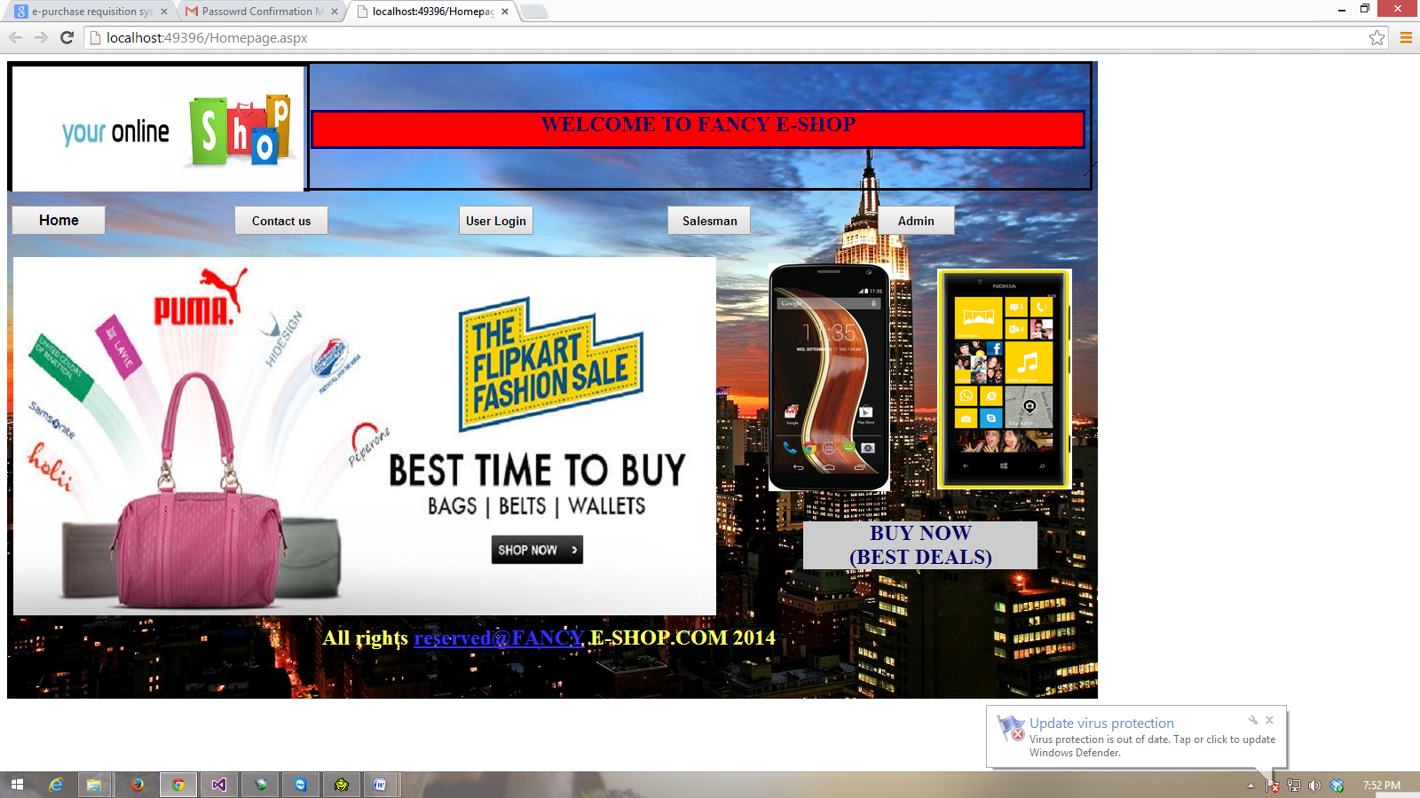

LOGIN PAGE

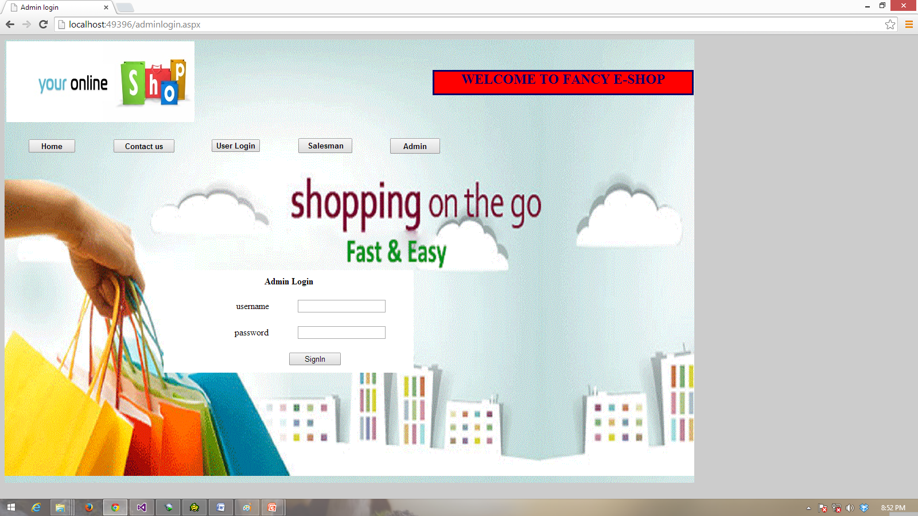

ADD NEW ITEM (ADMIN)

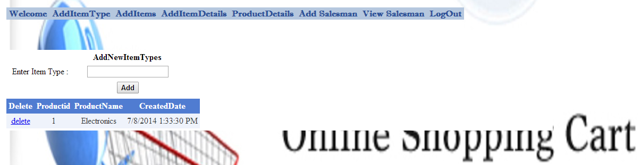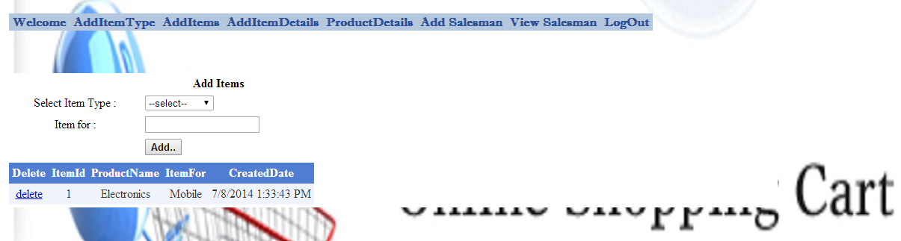

AVAILABLE PRODUCT DETAILS

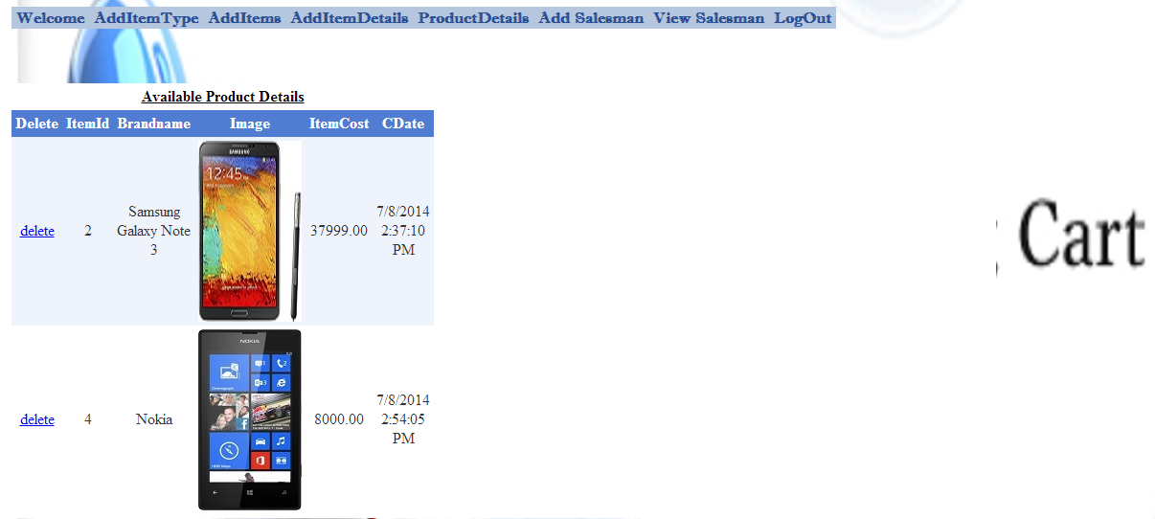

AVAILABLE PRODUCT DETAILS

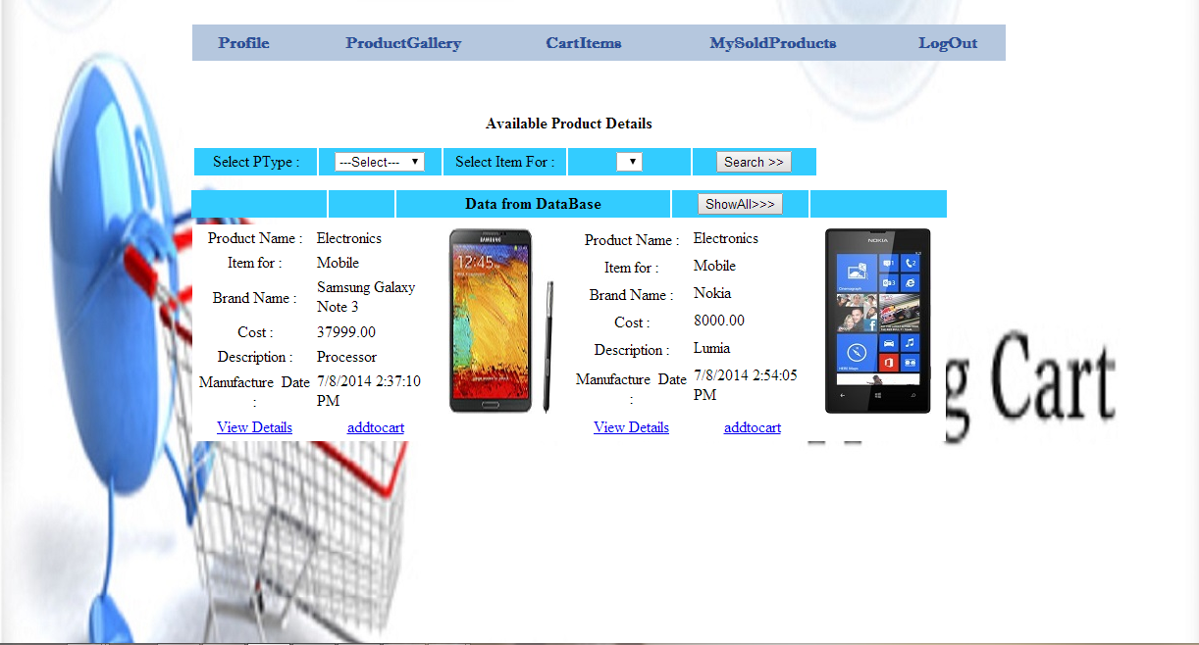

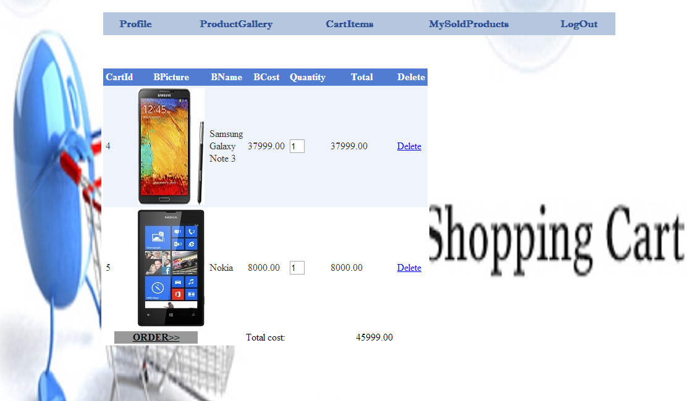

SALESMAN DETAILS

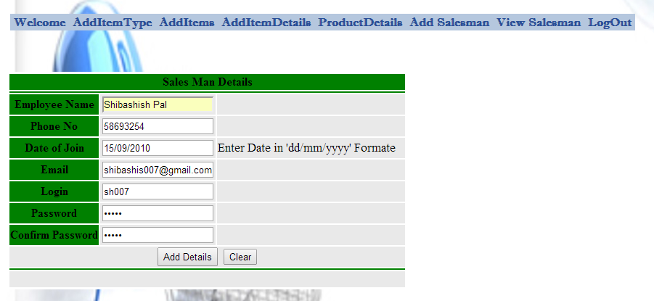

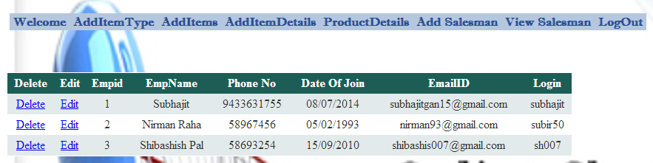

ADD ITEM DETAILS

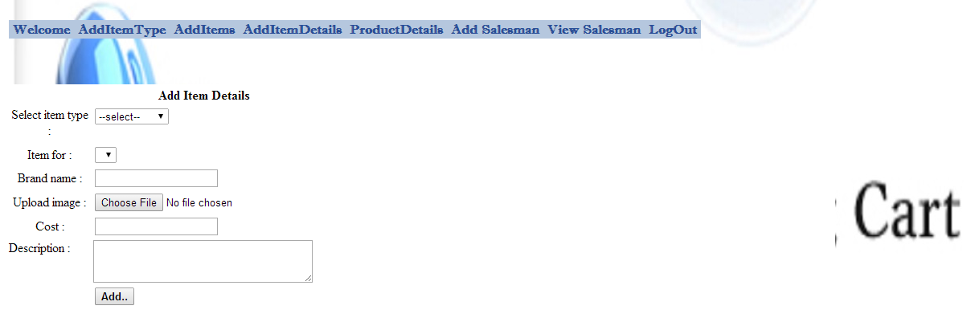

SHIPPING AND PAYMENT

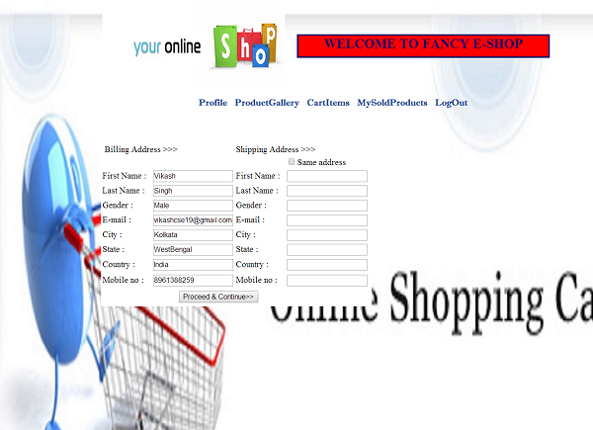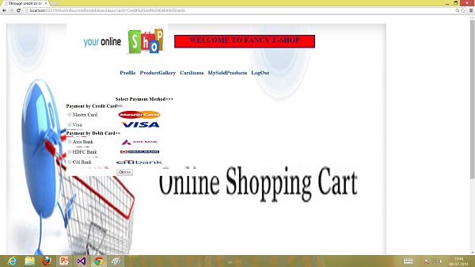

USER SIGNUP PROFILE

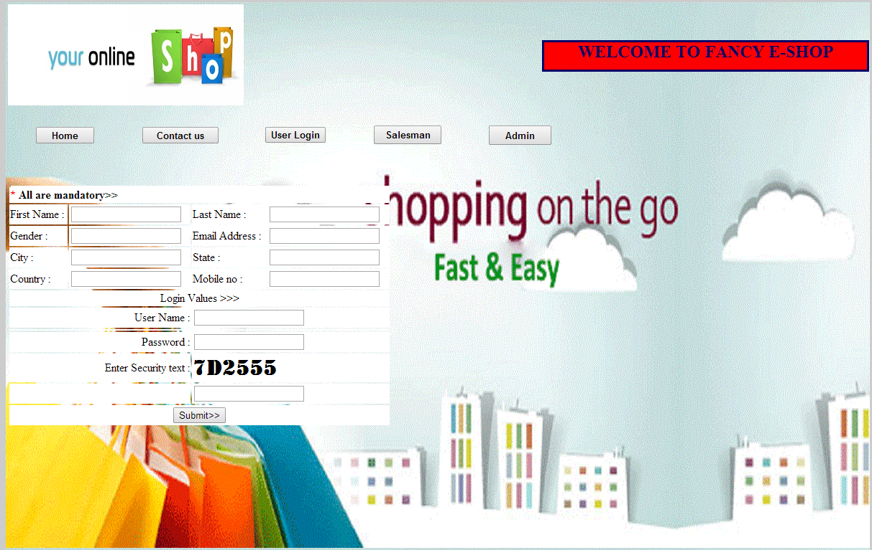

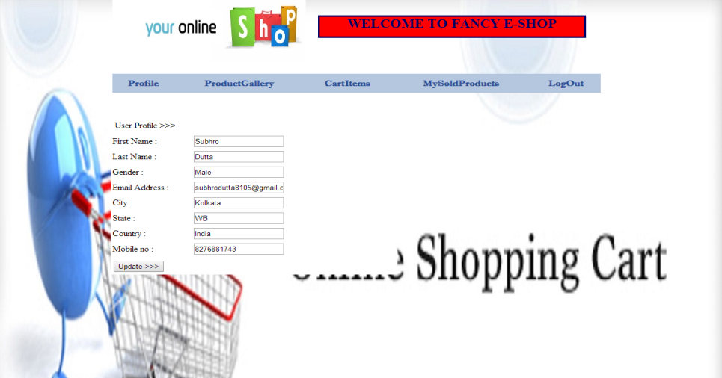

SALESMAN FUNCTIONS

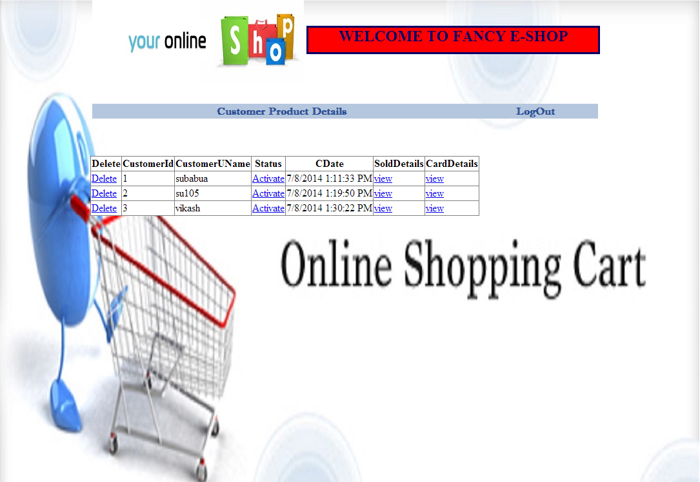

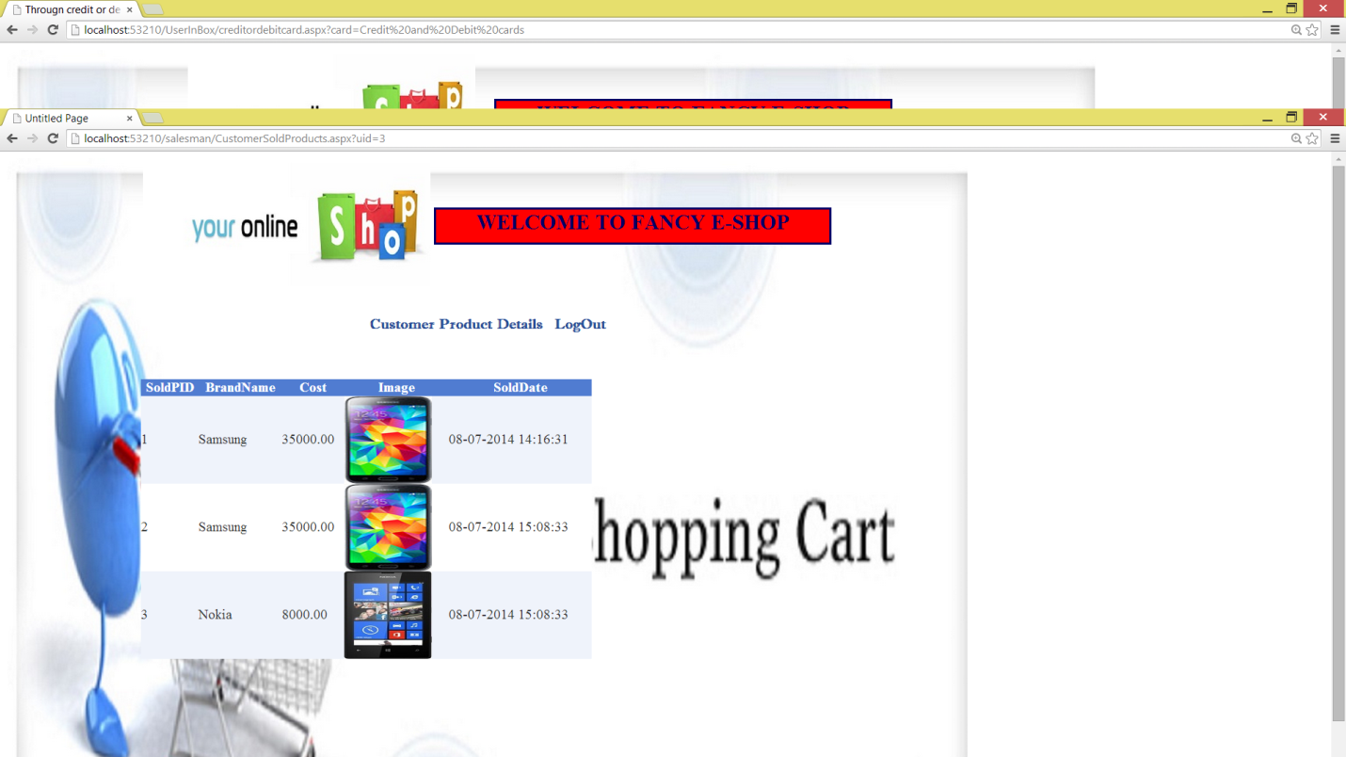

Future Scope of Improvements

The project **“E-Purchasing Requisition”** is something like the original grocery shop shopping cart that is used by the customer in selecting certain products. Finally after selection the customer confirms orders for all the purchasing items and submits his/her account details with tax information at the checkout counter.

 Shopping cart is used around the world in e-commerce to manage business through online. There are different kinds of software available that are useful for all in making purchase online. Through this software, one can choose the purchasing item and the software calculates the net amount for the order including packaging, moving and also taxes if applicable.

The software collects the credit card information of the customer and it provides a secure gateway for all kinds of transaction online. The shopping cart software provides a reliable platform for keeping all sensitive information. For this kind of online business, the special software must be installed on the server which host the site, or on a secure server which receives all sensitive data.

Shopping cart software is its **security** as better security can attract customer by protecting their personal information. Security features include encrypting information and using a reputable processing service for credit cards.

Using certain add-ons like that of the PayPal system in the future will further enhance the reputation of the website.

Code:

AddItemDetails.aspx

<%@ Page Language="C#" MasterPageFile="~/MasterPage2.master" AutoEventWireup="true" CodeFile="AddItemDetails.aspx.cs" Inherits="Admin_AddItemDetailst" Title="Add New Product type details" %>

<asp:Content ID="Content1" ContentPlaceHolderID="ContentPlaceHolder1" Runat="Server">

<div style="text-align: center">

<table style="width: 492px; position: static; height: 100px">

<tr>

<td colspan="3">

<strong>Add Item Details</strong></td>

</tr>

<tr>

<td style="width: 100px">

Select item type :</td>

<td align="left" style="width: 100px" valign="top">

<asp:DropDownList ID="DropDownList1" runat="server" AutoPostBack="True" OnSelectedIndexChanged="DropDownList1_SelectedIndexChanged"

Style="position: static">

</asp:DropDownList></td>

<td style="width: 100px">

</td>

</tr>

<tr>

<td colspan="3">

<asp:Label ID="Label1" runat="server" Style="position: static" Width="232px"></asp:Label></td>

</tr>

<tr>

<td style="width: 100px">

Item for :</td>

<td align="left" style="width: 100px" valign="top">

<asp:DropDownList ID="DropDownList2" runat="server" Style="position: static">

</asp:DropDownList></td>

<td style="width: 100px">

</td>

</tr>

<tr>

<td style="width: 100px">

Brand name :</td>

<td align="left" style="width: 100px" valign="top">

<asp:TextBox ID="TextBox1" runat="server" Style="position: static"></asp:TextBox></td>

<td style="width: 100px">

</td>

</tr>

<tr>

<td style="width: 100px">

Upload image :</td>

<td align="left" style="width: 100px" valign="top">

<asp:FileUpload ID="FileUpload1" runat="server" Style="position: static" /></td>

<td style="width: 100px">

</td>

</tr>

<tr>

<td style="width: 100px; height: 26px">

Cost :</td>

<td align="left" style="width: 100px; height: 26px" valign="top">

<asp:TextBox ID="TextBox2" runat="server" Style="position: static"></asp:TextBox></td>

<td style="width: 100px; height: 26px">

</td>

</tr>

<tr>

<td style="width: 100px" align="left" valign="top">

Description :</td>

<td align="left" style="width: 100px" valign="top">

<asp:TextBox ID="TextBox3" runat="server" Style="position: static" Height="47px" TextMode="MultiLine" Width="267px"></asp:TextBox></td>

<td style="width: 100px">

</td>

</tr>

<tr>

<td style="width: 100px">

</td>

<td align="left" style="width: 100px" valign="top">

<asp:Button ID="Button1" runat="server" Font-Bold="True" Style="position: static"

Text="Add.." OnClick="Button1_Click" /></td>

<td style="width: 100px">

</td>

</tr>

<tr>

<td colspan="3">

</td>

</tr>

<tr>

<td colspan="3">

</td>

</tr>

<tr>

<td colspan="3">

</td>

</tr>

</table>

</div>

</asp:Content>

AddItemDetails.aspx.cs

using System;

using System.Data;

using System.Configuration;

using System.Collections;

using System.Web;

using System.Web.Security;

using System.Web.UI;

using System.Web.UI.WebControls;

using System.Web.UI.WebControls.WebParts;

using System.Web.UI.HtmlControls;

using System.Data.SqlClient;

public partial class Admin_AddItemDetailst : System.Web.UI.Page

{

SqlConnection con = new SqlConnection(ConfigurationManager.ConnectionStrings["con"].ConnectionString);

SqlDataAdapter da;

DataSet ds;

protected void Page_Load(object sender, EventArgs e)

{

if (con.State == ConnectionState.Closed)

{

con.Open();

}

if (Page.IsPostBack != true)

{

GetItemType();

}

}

private void GetItemType()

{

da = new SqlDataAdapter("select pid,productname from tbl_products", con);

ds = new DataSet();

da.Fill(ds, "tbl_product");

if (ds.Tables.Count > 0 && ds.Tables["tbl_product"].Rows.Count > 0)

{

DropDownList1.DataSource = ds.Tables["tbl_product"];

DropDownList1.DataTextField = "productname";

DropDownList1.DataValueField = "pid";

DropDownList1.DataBind();

DropDownList1.Items.Insert(0, "--select--");

}

}

protected void DropDownList1_SelectedIndexChanged(object sender, EventArgs e)

{

if (DropDownList1.SelectedIndex > 0)

{

da = new SqlDataAdapter("select itemid,itemfor from tbl_itemsofproduct where pid="+Convert.ToInt32(DropDownList1.SelectedValue.ToString())+" ", con);

ds = new DataSet();

da.Fill(ds, "tbl_iofproduct");

if (ds.Tables.Count > 0 && ds.Tables["tbl_iofproduct"].Rows.Count > 0)

{

DropDownList2.DataSource = ds.Tables["tbl_iofproduct"];

DropDownList2.DataTextField = "itemfor";

DropDownList2.DataValueField = "itemid";

DropDownList2.DataBind();

DropDownList2.Items.Insert(0, "--select--");

Label1.Text = "";

}

else

{

Label1.Text = "There are no items for : " + DropDownList1.SelectedItem.Text;

DropDownList2.Items.Clear();

DropDownList2.Dispose();

}

}

}

protected void Button1_Click(object sender, EventArgs e)

{

if (FileUpload1.PostedFile.ContentLength > 0 && FileUpload1.HasFile == true)

{

string filename = Guid.NewGuid().ToString().Substring(0, 10) + "" + FileUpload1.PostedFile.FileName.Remove(0, FileUpload1.PostedFile.FileName.LastIndexOf("."));

FileUpload1.SaveAs(Server.MapPath("~/Allproductitems/" + filename.ToString()));

string imgpath = "~/Allproductitems/" + filename.ToString();

da = new SqlDataAdapter("insert into tbl_productitemdetails(pid,itemid,brandname,imagepath,cost,description,cdate) values(" + Convert.ToInt32(DropDownList1.SelectedValue.ToString()) + "," +Convert.ToInt32(DropDownList2.SelectedValue.ToString()) + ",'" + TextBox1.Text + "','" + imgpath.ToString() + "'," + Convert.ToDecimal(TextBox2.Text) + ",'" + TextBox3.Text + "',getdate())", con);

int n = da.SelectCommand.ExecuteNonQuery();

if (n == 1)

{

TextBox3.Text = "";

TextBox2.Text = "";

TextBox1.Text = "";

DropDownList1.SelectedIndex = 0;

DropDownList2.SelectedIndex = 0;

Response.Redirect("~/admin/productdetails.aspx");

}

}

}

}

AddItems.aspx

<%@ Page Language="C#" MasterPageFile="~/MasterPage2.master" AutoEventWireup="true" CodeFile="AddItems.aspx.cs" Inherits="Admin_AddItems" Title="Add Product item for" %>

<asp:Content ID="Content1" ContentPlaceHolderID="ContentPlaceHolder1" Runat="Server">

<div style="text-align: center">

<table style="width: 566px; position: static; height: 100px">

<tr>

<td colspan="3">

<strong>Add Items</strong></td>

</tr>

<tr>

<td style="width: 111px">

Select Item Type :</td>

<td style="width: 100px" align="left" valign="top">

<asp:DropDownList ID="DropDownList1" runat="server" Style="position: static">

</asp:DropDownList></td>

<td style="width: 100px">

</td>

</tr>

<tr>

<td style="width: 111px">

Item for :</td>

<td style="width: 100px" align="left" valign="top">

<asp:TextBox ID="TextBox1" runat="server" Style="position: static"></asp:TextBox></td>

<td style="width: 100px">

</td>

</tr>

<tr>

<td style="width: 111px">

</td>

<td style="width: 100px" align="left" valign="top">

<asp:Button ID="Button1" runat="server" OnClick="Button1_Click" Style="position: static"

Text="Add.." Font-Bold="True" /></td>

<td style="width: 100px">

</td>

</tr>

<tr>

<td style="width: 111px">

</td>

<td style="width: 100px">

</td>

<td style="width: 100px">

</td>

</tr>

<tr>

<td colspan="3">

<asp:GridView ID="GridView1" runat="server" CellPadding="4" ForeColor="#333333" GridLines="None"

Style="position: static" AutoGenerateColumns="False" AllowPaging="True" OnRowDeleting="GridView1_RowDeleting" OnPageIndexChanging="GridView1_PageIndexChanging">

<FooterStyle BackColor="#507CD1" Font-Bold="True" ForeColor="White" />

<RowStyle BackColor="#EFF3FB" />

<EditRowStyle BackColor="#2461BF" />

<SelectedRowStyle BackColor="#D1DDF1" Font-Bold="True" ForeColor="#333333" />

<PagerStyle BackColor="#2461BF" ForeColor="White" HorizontalAlign="Center" />

<HeaderStyle BackColor="#507CD1" Font-Bold="True" ForeColor="White" />

<AlternatingRowStyle BackColor="White" />

<Columns>

<asp:TemplateField HeaderText="Delete">

<ItemTemplate>

<asp:LinkButton ID="delete" runat="server" Text="Delete" CommandName="Delete"></asp:LinkButton>

</ItemTemplate>

</asp:TemplateField>

<asp:TemplateField HeaderText="ItemId">

<ItemTemplate>

<asp:Label ID="itemid" runat="server" Text='<%#Eval("itemid") %>'></asp:Label>

</ItemTemplate>

</asp:TemplateField>

<asp:TemplateField HeaderText="ProductName">

<ItemTemplate>

<asp:Label ID="pname" runat="server" Text='<%#Eval("productname") %>'></asp:Label>

</ItemTemplate>

</asp:TemplateField>

<asp:TemplateField HeaderText="ItemFor">

<ItemTemplate>

<asp:Label ID="itemfor" runat="server" Text='<%#Eval("itemfor") %>'></asp:Label>

</ItemTemplate>

</asp:TemplateField>

<asp:TemplateField HeaderText="CreatedDate">

<ItemTemplate>

<asp:Label ID="cdate" runat="server" Text='<%#Eval("cdate") %>'></asp:Label>

</ItemTemplate>

</asp:TemplateField>

</Columns>

<EmptyDataTemplate>

<strong>There are no Item Deatils.</strong>

</EmptyDataTemplate>

</asp:GridView>

</td>

</tr>

</table>

</div>

</asp:Content>

AddItems.aspx.cs

using System;

using System.Data;

using System.Configuration;

using System.Collections;

using System.Web;

using System.Web.Security;

using System.Web.UI;

using System.Web.UI.WebControls;

using System.Web.UI.WebControls.WebParts;

using System.Web.UI.HtmlControls;

using System.Data.SqlClient;

public partial class Admin_AddItems : System.Web.UI.Page

{

SqlConnection con = new SqlConnection(ConfigurationManager.ConnectionStrings["con"].ConnectionString);

SqlDataAdapter da;

DataSet ds;

protected void Page_Load(object sender, EventArgs e)

{

if (con.State == ConnectionState.Closed)

{

con.Open();

}

if (Page.IsPostBack!=true)

{

GetItemType();

Getitemsfor();

}

}

private void GetItemType()

{

da = new SqlDataAdapter("select pid,productname from tbl_products", con);

ds = new DataSet();

da.Fill(ds, "tbl_product");

if (ds.Tables.Count > 0 && ds.Tables["tbl_product"].Rows.Count > 0)

{

DropDownList1.DataSource = ds.Tables["tbl_product"];

DropDownList1.DataTextField = "productname";

DropDownList1.DataValueField = "pid";

DropDownList1.DataBind();

DropDownList1.Items.Insert(0, "--Select--");

}

}

private void Getitemsfor()

{

da = new SqlDataAdapter("select tip.itemid,tp.productname,tip.itemfor,tip.cdate from tbl_itemsofproduct tip inner join tbl_products tp on tip.pid=tp.pid", con);

ds = new DataSet();

da.Fill(ds, "tbl_tip");

GridView1.DataSource = ds.Tables["tbl_tip"].DefaultView;

GridView1.DataBind();

}

protected void Button1_Click(object sender, EventArgs e)

{

if (TextBox1.Text != "")

{

da = new SqlDataAdapter("insert into tbl_itemsofproduct(pid,itemfor,cdate)values(" + Convert.ToInt32(DropDownList1.SelectedValue.ToString()) + ",'" + TextBox1.Text + "',getdate())", con);

int n = da.SelectCommand.ExecuteNonQuery();

if (n == 1)

{

Getitemsfor();

TextBox1.Text = "";

DropDownList1.SelectedIndex = 0;

}

}

}

protected void GridView1_RowDeleting(object sender, GridViewDeleteEventArgs e)

{

Label itemid = new Label();

itemid = (Label)GridView1.Rows[e.RowIndex].Cells[1].FindControl("itemid");

if (itemid.Text != "")

{

da = new SqlDataAdapter("delete from tbl_itemsofproduct where itemid=" + Convert.ToInt32(itemid.Text) + " ", con);

int n = da.SelectCommand.ExecuteNonQuery();

if (n == 1)

{

Getitemsfor();

}

}

}

protected void GridView1_PageIndexChanging(object sender, GridViewPageEventArgs e)

{

GridView1.PageIndex = e.NewPageIndex;

Getitemsfor();

}

}

AddItemType.aspx

<%@ Page Language="C#" MasterPageFile="~/MasterPage2.master" AutoEventWireup="true" CodeFile="AddItemType.aspx.cs" Inherits="Admin_AddItemType" Title="Add new product type" %>

<asp:Content ID="c1" ContentPlaceHolderID="ContentPlaceHolder1" runat="server">

<div style="text-align: center">

<table style="width: 460px; position: static; height: 100px">

<tr>

<td colspan="3">

<strong>AddNewItemTypes</strong></td>

</tr>

<tr>

<td style="width: 100px; height: 19px">

Enter Item Type :</td>

<td style="width: 100px; height: 19px">

<asp:TextBox ID="TextBox1" runat="server" Style="position: static"></asp:TextBox></td>

<td style="width: 100px; height: 19px">

</td>

</tr>

<tr>

<td style="width: 100px">

</td>

<td style="width: 100px">

<asp:Button ID="Button1" runat="server" OnClick="Button1_Click" Style="position: static"

Text="Add" Font-Bold="True" /></td>

<td style="width: 100px">

</td>

</tr>

<tr>

<td style="width: 100px">

</td>

<td style="width: 100px">

</td>

<td style="width: 100px">

</td>

</tr>

<tr>

<td colspan="3">

<asp:GridView ID="GridView1" runat="server" CellPadding="4" ForeColor="#333333" GridLines="None"

Style="position: static" AutoGenerateColumns="False" OnRowDeleting="GridView1_RowDeleting" AllowPaging="True" OnPageIndexChanging="GridView1_PageIndexChanging" >

<FooterStyle BackColor="#507CD1" Font-Bold="True" ForeColor="White" />

<RowStyle BackColor="#EFF3FB" />

<EditRowStyle BackColor="#2461BF" />

<SelectedRowStyle BackColor="#D1DDF1" Font-Bold="True" ForeColor="#333333" />

<PagerStyle BackColor="#2461BF" ForeColor="White" HorizontalAlign="Center" />

<HeaderStyle BackColor="#507CD1" Font-Bold="True" ForeColor="White" />

<AlternatingRowStyle BackColor="White" />

<Columns>

<asp:TemplateField HeaderText="Delete">

<ItemTemplate>

<asp:LinkButton ID="delete" runat="server" Text="Delete" CommandName="Delete"></asp:LinkButton>

</ItemTemplate>

</asp:TemplateField>

<asp:TemplateField HeaderText="Productid">

<ItemTemplate>

<asp:Label ID="pid" runat="server" Text='<%#Eval("pid") %>'></asp:Label>

</ItemTemplate>

</asp:TemplateField>

<asp:TemplateField HeaderText="ProductName">

<ItemTemplate>

<asp:Label ID="pname" runat="server" Text='<%#Eval("productname") %>'></asp:Label>

</ItemTemplate>

</asp:TemplateField>

<asp:TemplateField HeaderText="CreatedDate">

<ItemTemplate>

<asp:Label ID="cdate" runat="server" Text='<%#Eval("cdate") %>'></asp:Label>

</ItemTemplate>

</asp:TemplateField>

</Columns>

<EmptyDataTemplate>

<strong>There no Item Type Available.</strong>

</EmptyDataTemplate>

</asp:GridView>

</td>

</tr>

</table>

</div>

</asp:Content>

AddItemType.aspx.cs

using System;

using System.Data;

using System.Configuration;

using System.Collections;

using System.Web;

using System.Web.Security;

using System.Web.UI;

using System.Web.UI.WebControls;

using System.Web.UI.WebControls.WebParts;

using System.Web.UI.HtmlControls;

using System.Data.SqlClient;

public partial class Admin_AddItemType : System.Web.UI.Page

{

SqlConnection con = new SqlConnection(ConfigurationManager.ConnectionStrings["con"].ConnectionString);

SqlDataAdapter da;

DataSet ds;

protected void Page_Load(object sender, EventArgs e)

{

if (con.State == ConnectionState.Closed)

{

con.Open();

}

if (Page.IsPostBack != true)

{

GetItemTypes();

}

}

private void GetItemTypes()

{

da = new SqlDataAdapter("select pid,productname,cdate from tbl_products", con);

ds = new DataSet();

da.Fill(ds, "tbl_product");

GridView1.DataSource = ds.Tables["tbl_product"].DefaultView;

GridView1.DataBind();

}

protected void Button1_Click(object sender, EventArgs e)

{

da = new SqlDataAdapter("insert into tbl_products(productname,cdate)values('" + TextBox1.Text + "',getdate())", con);

int n= da.SelectCommand.ExecuteNonQuery();

if (n == 1)

{

GetItemTypes();

TextBox1.Text = "";

}

}

protected void GridView1_RowDeleting(object sender, GridViewDeleteEventArgs e)

{

Label pid = new Label();

pid = (Label)GridView1.Rows[e.RowIndex].Cells[1].FindControl("pid");

if (pid.Text != "")

{

da = new SqlDataAdapter("delete from tbl_products where pid=" + Convert.ToInt32(pid.Text) + " ", con);

int n = da.SelectCommand.ExecuteNonQuery();

if (n == 1)

{

GetItemTypes();

}

}

}

protected void GridView1_PageIndexChanging(object sender, GridViewPageEventArgs e)

{

GridView1.PageIndex = e.NewPageIndex;

GetItemTypes();

}

}

addsalesman.aspx

<%@ Page Language="C#" MasterPageFile="~/MasterPage2.master" AutoEventWireup="true" CodeFile="addsalesman.aspx.cs" Inherits="Admin_addsalesman" Title="Untitled Page" %>

<asp:Content ID="Content1" ContentPlaceHolderID="ContentPlaceHolder1" Runat="Server">

<table>

<tr>

<td align="center" colspan="3"

style="font-weight: bolder; font-size: 16px; background-color: #008000">

Sales Man Details

</td>

</tr>

<tr>

<td align="center" colspan="3"

style="font-weight: bolder; font-size: 16px; background-color: #008000">

<asp:Label ID="Label2" runat="server"></asp:Label>

</td>

</tr>

<tr>

<td style="font-weight: bolder; font-size: 16px; background-color: #008000">

Employee Name</td>

<td style="background-color: #e9e9e9">

<asp:TextBox ID="txtname" runat="server"></asp:TextBox>

</td>

<td style="background-color: #e9e9e9">

<asp:RequiredFieldValidator ID="RequiredFieldValidator1" runat="server"

ControlToValidate="txtname" ErrorMessage="*"></asp:RequiredFieldValidator>

</td>

</tr>

<tr style="color: #000000">

<td style="font-weight: bolder; font-size: 16px; background-color: #008000">

Phone No</td>

<td style="background-color: #e9e9e9">

<asp:TextBox ID="txtphno" runat="server"></asp:TextBox>

</td>

<td style="background-color: #e9e9e9">

<asp:RequiredFieldValidator ID="RequiredFieldValidator3" runat="server"

ControlToValidate="txtphno" ErrorMessage="*"></asp:RequiredFieldValidator>

</td>

</tr>

<tr style="color: #000000">

<td style="font-weight: bolder; font-size: 16px; background-color: #008000">

Date of Join</td>

<td style="background-color: #e9e9e9">

<asp:TextBox ID="txtdoj" runat="server"></asp:TextBox>

</td>

<td style="background-color: #e9e9e9">

<asp:Label ID="Label1" runat="server" Font-Size="13pt"

Text="Enter Date in 'dd/mm/yyyy' Formate"></asp:Label>

<asp:RequiredFieldValidator ID="RequiredFieldValidator2" runat="server"

ControlToValidate="txtdoj" ErrorMessage="*"></asp:RequiredFieldValidator>

</td>

</tr>

<tr>

<td style="font-weight: bolder; font-size: 16px; background-color: #008000">

Email</td>

<td style="background-color: #e9e9e9">

<asp:TextBox ID="txtemail" runat="server"></asp:TextBox>

</td>

<td style="background-color: #e9e9e9">

<asp:RequiredFieldValidator ID="RequiredFieldValidator4" runat="server"

ControlToValidate="txtemail" ErrorMessage="*"></asp:RequiredFieldValidator>

</td>

</tr>

<tr>

<td style="font-weight: bolder; font-size: 16px; background-color: #008000">

Login</td>

<td style="background-color: #e9e9e9">

<asp:TextBox ID="txtlogin" runat="server"></asp:TextBox>

</td>

<td style="background-color: #e9e9e9">

<asp:RequiredFieldValidator ID="RequiredFieldValidator5" runat="server"

ControlToValidate="txtlogin" ErrorMessage="*"></asp:RequiredFieldValidator>

</td>

</tr>

<tr>

<td style="font-weight: bolder; font-size: 16px; background-color: #008000">

Password</td>

<td style="background-color: #e9e9e9">

<asp:TextBox ID="txtpwd" runat="server" TextMode="Password"></asp:TextBox>

</td>

<td style="background-color: #e9e9e9">

<asp:RequiredFieldValidator ID="RequiredFieldValidator6" runat="server"

ControlToValidate="txtpwd" ErrorMessage="*"></asp:RequiredFieldValidator>

</td>

</tr>

<tr>

<td style="font-weight: bolder; font-size: 16px; background-color: #008000">

Confirm Password</td>

<td style="background-color: #e9e9e9">

<asp:TextBox ID="txtcpwd" runat="server" TextMode="Password"></asp:TextBox>

</td>

<td style="background-color: #e9e9e9">

<asp:CompareValidator ID="CompareValidator1" runat="server"

ControlToCompare="txtpwd" ControlToValidate="txtcpwd"

ErrorMessage="Invalid Password"></asp:CompareValidator>

</td>

</tr>

<tr>

<td align="center" colspan="3"

style="font-weight: bolder; font-size: 16px; background-color: #e9e9e9">

<asp:Button ID="btnadd" runat="server" OnClick="btnadd_Click"

style="height: 26px" Text="Add Details" />

<asp:Button ID="btnclear" runat="server" CausesValidation="False"

Text="Clear" />

</td>

</tr>

<tr>

<td colspan="3"

style="font-weight: bolder; font-size: 16px; background-color: #008000">

</td>

</tr>

<tr>

<td align="center" colspan="3"

style="font-weight: bolder; font-size: 16px; background-color: #e9e9e9">

&nbsp;

</td>

</tr>

</table>

</asp:Content>

addsalesman.aspx.cs

using System;

using System.Collections;

using System.Configuration;

using System.Data;

using System.Linq;

using System.Web;

using System.Web.Security;

using System.Web.UI;

using System.Web.UI.HtmlControls;

using System.Web.UI.WebControls;

using System.Web.UI.WebControls.WebParts;

using System.Xml.Linq;

using System.Data.SqlClient;

public partial class Admin_addsalesman : System.Web.UI.Page

{

SqlConnection con = new SqlConnection(ConfigurationManager.ConnectionStrings["con"].ConnectionString);

SqlCommand cmd;

SqlDataAdapter da;

DataSet ds;

protected void Page_Load(object sender, EventArgs e)

{

}

protected void btnadd_Click(object sender, EventArgs e)

{

cmd = new SqlCommand("insert into tbl_newemp values('" + txtname.Text + "','" + txtphno.Text + "','" + txtdoj.Text + "','" + txtemail.Text + "','" + txtlogin.Text + "','" + txtpwd.Text + "')", con);

con.Open();

int k = cmd.ExecuteNonQuery();

con.Close();

if (k == 1)

{

Response.Write("<script>alert('Employee Details Added')</script>");

}

else

{

Response.Write("<script>alert('Error Occured')</script>");

}

}

}

productdetails.aspx

<%@ Page Language="C#" MasterPageFile="~/MasterPage2.master" AutoEventWireup="true" CodeFile="productdetails.aspx.cs" Inherits="Admin_productdetails" Title="All product details list" %>

<asp:Content ID="Content1" ContentPlaceHolderID="ContentPlaceHolder1" Runat="Server">

<div style="text-align: center">

<table style="width: 370px; position: static; height: 18px">

<tr>

<td style="width: 100px">

<strong><span style="text-decoration: underline">Available Product Details</span></strong></td>

</tr>

<tr>

<td style="width: 100px">

<asp:GridView ID="GridView1" runat="server" AllowPaging="True" AutoGenerateColumns="False"

CellPadding="4" ForeColor="#333333" GridLines="None" PageSize="6" Style="position: static" OnRowDeleting="GridView1_RowDeleting" OnPageIndexChanging="GridView1_PageIndexChanging">

<FooterStyle BackColor="#507CD1" Font-Bold="True" ForeColor="White" />

<RowStyle BackColor="#EFF3FB" />

<EditRowStyle BackColor="#2461BF" />

<SelectedRowStyle BackColor="#D1DDF1" Font-Bold="True" ForeColor="#333333" />

<PagerStyle BackColor="#2461BF" ForeColor="White" HorizontalAlign="Center" />

<HeaderStyle BackColor="#507CD1" Font-Bold="True" ForeColor="White" />

<AlternatingRowStyle BackColor="White" />

<Columns>

<asp:TemplateField HeaderText="Delete">

<ItemTemplate>

<asp:LinkButton ID="delete" runat="server" Text="delete" CommandName="Delete"></asp:LinkButton>

</ItemTemplate>

</asp:TemplateField>

<asp:TemplateField HeaderText="ItemId">

<ItemTemplate>

<asp:Label ID="itemid" runat="server" Text='<%#Eval("pitemdid") %>'></asp:Label>

</ItemTemplate>

</asp:TemplateField>

<asp:TemplateField HeaderText="Brandname">

<ItemTemplate>

<asp:Label ID="bname" runat="server" Text='<%#Eval("Brandname") %>'></asp:Label>

</ItemTemplate>

</asp:TemplateField>

<asp:TemplateField HeaderText="Image">

<ItemTemplate>

<asp:Image ID="img" runat="server" ImageUrl='<%#Eval("imagepath") %>' Width="108px" Height="189px" />

</ItemTemplate>

</asp:TemplateField>

<asp:TemplateField HeaderText="ItemCost">

<ItemTemplate>

<asp:Label ID="cost" runat="server" Text='<%#Eval("cost") %>'></asp:Label>

</ItemTemplate>

</asp:TemplateField>

<asp:TemplateField HeaderText="CDate">

<ItemTemplate>

<asp:Label ID="cdate" runat="server" Text='<%#Eval("cdate") %>'></asp:Label>

</ItemTemplate>

</asp:TemplateField>

</Columns>

</asp:GridView>

</td>

</tr>

</table>

</div>

</asp:Content>

productdetails.aspx.cs

using System;

using System.Data;

using System.Configuration;

using System.Collections;

using System.Web;

using System.Web.Security;

using System.Web.UI;

using System.Web.UI.WebControls;

using System.Web.UI.WebControls.WebParts;

using System.Web.UI.HtmlControls;

using System.Data.SqlClient;

public partial class Admin_productdetails : System.Web.UI.Page

{

SqlConnection con = new SqlConnection(ConfigurationManager.ConnectionStrings["con"].ConnectionString);

SqlDataAdapter da;

DataSet ds;

protected void Page_Load(object sender, EventArgs e)

{

if (con.State == ConnectionState.Closed)

{

con.Open();

}

if (!Page.IsPostBack)

{

Getproductdetails();

}

}

private void Getproductdetails()

{

da = new SqlDataAdapter("select pitemdid,brandname,imagepath,cost,description,cdate from tbl_productitemdetails", con);

ds = new DataSet();

da.Fill(ds, "tbl_pidetails");

GridView1.DataSource = ds.Tables["tbl_pidetails"].DefaultView;

GridView1.DataBind();

}

protected void GridView1_RowDeleting(object sender, GridViewDeleteEventArgs e)

{

Label itemid = new Label();

itemid = (Label)GridView1.Rows[e.RowIndex].Cells[1].FindControl("itemid");

if (itemid.Text != "")

{

da = new SqlDataAdapter("delete from tbl_productitemdetails where pitemdid=" + Convert.ToInt32(itemid.Text) + " ", con);

int n = da.SelectCommand.ExecuteNonQuery();

if (n == 1)

{

Getproductdetails();

}

}

}

protected void GridView1_PageIndexChanging(object sender, GridViewPageEventArgs e)

{

GridView1.PageIndex = e.NewPageIndex;

Getproductdetails();

}

}

view salesmandetails.aspx

<%@ Page Language="C#" MasterPageFile="~/MasterPage2.master" AutoEventWireup="true" CodeFile="view salesmandetails.aspx.cs" Inherits="Admin_view_salesmandetails" Title="Untitled Page" %>

<asp:Content ID="Content1" ContentPlaceHolderID="ContentPlaceHolder1" Runat="Server">

<asp:GridView ID="GridView1" runat="server" AllowPaging="True"

AutoGenerateColumns="False" CellPadding="4" ForeColor="#333333"

GridLines="None" Height="92px"

OnPageIndexChanging="GridView1_PageIndexChanging"

onrowcancelingedit="GridView1_RowCancelingEdit"

onrowdeleting="GridView1_RowDeleting" onrowediting="GridView1_RowEditing"

onrowupdating="GridView1_RowUpdating" PageSize="4" Width="763px">

<RowStyle BackColor="#E3EAEB" />

<Columns>

<asp:TemplateField HeaderText="Delete">

<ItemTemplate>

<asp:LinkButton ID="Delete" runat="server" CommandName="Delete" Text="Delete"></asp:LinkButton>

</ItemTemplate>

</asp:TemplateField>

<asp:TemplateField HeaderText="Edit">

<ItemTemplate>

<asp:LinkButton ID="Edit" runat="server" CommandName="Edit" Text="Edit"></asp:LinkButton>

</ItemTemplate>

<EditItemTemplate>

<asp:LinkButton ID="Update" runat="server" CommandName="Update" Text="Update"></asp:LinkButton>

<asp:LinkButton ID="Cancel" runat="server" CommandName="Cancel" Text="Cancel"></asp:LinkButton>

</EditItemTemplate>

</asp:TemplateField>

<asp:TemplateField HeaderText="Empid">

<ItemTemplate>

<asp:Label ID="empid" runat="server" Text='<%#Eval("eid")%>'></asp:Label>

</ItemTemplate>

<EditItemTemplate>

<asp:Label ID="empid1" runat="server" Text='<%#Eval("eid")%>'></asp:Label>

</EditItemTemplate>

</asp:TemplateField>

<asp:TemplateField HeaderText="EmpName">

<ItemTemplate>

<asp:Label ID="empname" runat="server" Text='<%#Eval("ename")%>'></asp:Label>

</ItemTemplate>

</asp:TemplateField>

<asp:TemplateField HeaderText="Phone No">

<ItemTemplate>

<asp:Label ID="phno" runat="server" Text='<%#Eval("phno")%>'></asp:Label>

</ItemTemplate>

<EditItemTemplate>

<asp:TextBox ID="phno1" runat="server" Text='<%#Eval("phno")%>'></asp:TextBox>

</EditItemTemplate>

</asp:TemplateField>

<asp:TemplateField HeaderText="Date Of Join">

<ItemTemplate>

<asp:Label ID="doj" runat="server" Text='<%#Eval("doj")%>'></asp:Label>

</ItemTemplate>

</asp:TemplateField>

<asp:TemplateField HeaderText="EmailID">

<ItemTemplate>

<asp:Label ID="emailid" runat="server" Text='<%#Eval("email")%>'></asp:Label>

</ItemTemplate>

<EditItemTemplate>

<asp:TextBox ID="emailid1" runat="server" Text='<%#Eval("email")%>'></asp:TextBox>

</EditItemTemplate>

</asp:TemplateField>

<asp:TemplateField HeaderText="Login">

<ItemTemplate>

<asp:Label ID="login" runat="server" Text='<%#Eval("login")%>'></asp:Label>

</ItemTemplate>

</asp:TemplateField>

</Columns>

<FooterStyle BackColor="#1C5E55" Font-Bold="True" ForeColor="White" />

<PagerStyle BackColor="#666666" ForeColor="White" HorizontalAlign="Center" />

<SelectedRowStyle BackColor="#C5BBAF" Font-Bold="True" ForeColor="#333333" />

<HeaderStyle BackColor="#1C5E55" Font-Bold="True" ForeColor="White" />

<EditRowStyle BackColor="#7C6F57" />

<AlternatingRowStyle BackColor="White" />

</asp:GridView>

</asp:Content>

view salesmandetails.aspx.cs

using System;

using System.Collections;

using System.Configuration;

using System.Data;

using System.Linq;

using System.Web;

using System.Web.Security;

using System.Web.UI;

using System.Web.UI.HtmlControls;

using System.Web.UI.WebControls;

using System.Web.UI.WebControls.WebParts;

using System.Xml.Linq;

using System.Data.SqlClient;

public partial class Admin_view_salesmandetails : System.Web.UI.Page

{

SqlConnection con = new SqlConnection(ConfigurationManager.ConnectionStrings["con"].ConnectionString);

SqlCommand cmd;

SqlDataAdapter da;

DataSet ds;

protected void Page_Load(object sender, EventArgs e)

{

if (Page.IsPostBack != true)

{

getdetails();

}

}

private void getdetails()

{

da = new SqlDataAdapter("select * from tbl_newemp", con);

ds = new DataSet();

da.Fill(ds, "newemp");

GridView1.DataSource = ds.Tables["newemp"];

GridView1.DataBind();

}

protected void GridView1_RowDeleting(object sender, GridViewDeleteEventArgs e)

{

Label eid = new Label();

eid = (Label)GridView1.Rows[e.RowIndex].Cells[2].FindControl("eid");

cmd = new SqlCommand("delete from tbl_newemp where eid=" + eid.Text + "", con);

con.Open();

int k = cmd.ExecuteNonQuery();

con.Close();

if (k == 1)

{

Response.Write("<script>alert('Employee Deleted Successfully')</script>");

getdetails();

}

else

{

Response.Write("<script>alert('Error Occured While Deleting')</script>");

getdetails();

}

}

protected void GridView1_RowEditing(object sender, GridViewEditEventArgs e)

{

GridView1.EditIndex = e.NewEditIndex;

getdetails();

}

protected void GridView1_RowUpdating(object sender, GridViewUpdateEventArgs e)

{

Label eid = new Label();

TextBox phno = new TextBox();

TextBox emailid = new TextBox();

eid = (Label)GridView1.Rows[e.RowIndex].Cells[2].FindControl("empid1");

phno = (TextBox)GridView1.Rows[e.RowIndex].Cells[5].FindControl("phno1");

emailid = (TextBox)GridView1.Rows[e.RowIndex].Cells[7].FindControl("emailid1");

cmd = new SqlCommand("update tbl_newemp set phno='" + phno.Text + "', email='" + emailid.Text + "' where eid=" + eid.Text + "", con);

con.Open();

int k = cmd.ExecuteNonQuery();

con.Close();

if (k == 1)

{

Response.Write("<script>alert('Employee Updated Successfully')</script>");

GridView1.EditIndex = -1;

getdetails();

}

else

{

Response.Write("<script>alert('Error Occured While Updating')</script>");

getdetails();

}

}

protected void GridView1_RowCancelingEdit(object sender, GridViewCancelEditEventArgs e)

{

GridView1.EditIndex = -1;

getdetails();

}

protected void GridView1_PageIndexChanging(object sender, GridViewPageEventArgs e)

{

GridView1.PageIndex = e.NewPageIndex;

getdetails();

}

}

Welcome.aspx

<%@ Page Language="C#" MasterPageFile="~/MasterPage2.master" AutoEventWireup="true" CodeFile="Welcome.aspx.cs" Inherits="Admin_Welcome" Title="welcome to the admin panel" %>

<asp:Content ID="c1" ContentPlaceHolderID="ContentPlaceHolder1" runat="server">

welcome to admin

</asp:Content>

Welcome.aspx.cs

using System;

using System.Data;

using System.Configuration;

using System.Collections;

using System.Web;

using System.Web.Security;

using System.Web.UI;

using System.Web.UI.WebControls;

using System.Web.UI.WebControls.WebParts;

using System.Web.UI.HtmlControls;

public partial class Admin_Welcome : System.Web.UI.Page

{

protected void Page_Load(object sender, EventArgs e)

{

}

}

AddToCart.aspx.cs

using System;

using System.Data;

using System.Configuration;

using System.Collections;

using System.Web;

using System.Web.Security;

using System.Web.UI;

using System.Web.UI.WebControls;

using System.Web.UI.WebControls.WebParts;

using System.Web.UI.HtmlControls;

using System.Data.SqlClient;

public partial class UserInBox_AddtoCart : System.Web.UI.Page

{

SqlConnection con = new SqlConnection(ConfigurationManager.ConnectionStrings["con"].ConnectionString);

SqlDataAdapter da;

DataSet ds;

decimal totcost = 0;

protected void Page_Load(object sender, EventArgs e)

{

if (con.State == ConnectionState.Closed)

{

con.Open();

}

if (Page.IsPostBack != true)

{

GetUserSelectedproducts(Convert.ToInt32(Session["uid"].ToString()));

GetTotal();

}

}

private void GetUserSelectedproducts(int uid)

{

da = new SqlDataAdapter("select tatc.cartid,tatc.bname,tatc.imgpath,tatc.cost,tatc.qty,tatc.totcost from tbl_addtocart tatc inner join tbl_login tl on tl.uid=tatc.uid where tatc.uid=" + uid + " ", con);

ds = new DataSet();

da.Fill(ds, "tbl_tatc");

GridView1.DataSource = ds.Tables["tbl_tatc"].DefaultView;

GridView1.DataBind();

}

protected void qty_TextChanged(object sender, EventArgs e)

{

foreach (GridViewRow gr in GridView1.Rows)

{

TextBox qty = (TextBox)gr.Cells[4].FindControl("qty");

int quantity = Convert.ToInt32(qty.Text);

Label cartid = (Label)gr.Cells[0].FindControl("cartid");

Label cost = (Label)gr.Cells[3].FindControl("cost");

decimal totcost1 = Convert.ToDecimal(cost.Text);

totcost1 = totcost1 * quantity;

gr.Cells[5].Text = totcost1.ToString();

totcost = totcost + totcost1;

if (cartid.Text != "")

{

da = new SqlDataAdapter("update tbl_addtocart set qty=" + quantity + ",totcost="+totcost1+" where cartid=" + Convert.ToInt32(cartid.Text) + " and uid=" + Convert.ToInt32(Session["uid"].ToString()) + " ", con);

int n = da.SelectCommand.ExecuteNonQuery();

if (n == 1)

{

GetUserSelectedproducts(Convert.ToInt32(Session["uid"].ToString()));

}

}

//gr.Cells[5].Text=

}

Label1.Text = totcost.ToString();

}

private void GetTotal()

{

foreach (GridViewRow gr in GridView1.Rows)

{

Label tcost = (Label)gr.Cells[5].FindControl("tcost");

decimal totalcost = Convert.ToDecimal(tcost.Text);

totcost = totcost+totalcost;

}

Label1.Text = totcost.ToString();

}

protected void GridView1_RowDeleting(object sender, GridViewDeleteEventArgs e)

{

Label cartid = new Label();

cartid = (Label)GridView1.Rows[e.RowIndex].Cells[0].FindControl("cartid");

if (cartid.Text != "")

{

da = new SqlDataAdapter("delete from tbl_addtocart where cartid=" + Convert.ToInt32(cartid.Text) + " and uid=" + Convert.ToInt32(Session["uid"].ToString()) + " ", con);

int n=da.SelectCommand.ExecuteNonQuery();

if (n == 1)

{

GetUserSelectedproducts(Convert.ToInt32(Session["uid"].ToString()));

GetTotal();

}

}

}

protected void LinkButton1_Click(object sender, EventArgs e)

{

if (Convert.ToDecimal(Label1.Text)>0)

{

Response.Redirect("~/UserInBox/billingandshopping.aspx");

}

}

protected void GridView1_PageIndexChanging(object sender, GridViewPageEventArgs e)

{

GridView1.PageIndex = e.NewPageIndex;

GetUserSelectedproducts(Convert.ToInt32(Session["uid"].ToString()));

}

}

Billingandshopping.aspx.cs

using System;

using System.Data;

using System.Configuration;

using System.Collections;

using System.Web;

using System.Web.Security;

using System.Web.UI;

using System.Web.UI.WebControls;

using System.Web.UI.WebControls.WebParts;

using System.Web.UI.HtmlControls;

using System.Data.SqlClient;

public partial class user_billingandshopping : System.Web.UI.Page

{

SqlConnection con = new SqlConnection(ConfigurationManager.ConnectionStrings["con"].ConnectionString);

SqlDataAdapter da;

DataSet ds;

protected void Page_Load(object sender, EventArgs e)

{

if (con.State == ConnectionState.Closed)

{

con.Open();

}

if (!Page.IsPostBack)

{

GetBillingDetails(Convert.ToInt32(Session["uid"].ToString()));

}

}

private void GetBillingDetails(int uid)

{

da = new SqlDataAdapter("select fname,lname,gender,email,city,state,country,mobileno from tbl_contact where uid=" + uid + " ", con);

ds = new DataSet();

da.Fill(ds, "tbl_contact");

if (ds.Tables.Count > 0 && ds.Tables["tbl_contact"].Rows.Count > 0)

{

TextBox1.Text = ds.Tables["tbl_contact"].Rows[0][0].ToString();

TextBox2.Text = ds.Tables["tbl_contact"].Rows[0][1].ToString();

TextBox3.Text = ds.Tables["tbl_contact"].Rows[0][2].ToString();

TextBox4.Text = ds.Tables["tbl_contact"].Rows[0][3].ToString();

TextBox5.Text = ds.Tables["tbl_contact"].Rows[0][4].ToString();

TextBox6.Text = ds.Tables["tbl_contact"].Rows[0][5].ToString();

TextBox7.Text = ds.Tables["tbl_contact"].Rows[0][6].ToString();

TextBox9.Text = ds.Tables["tbl_contact"].Rows[0][7].ToString();

}

}

protected void Button1_Click(object sender, EventArgs e)

{

if (Page.IsValid == true)

{

if (TextBox10.Text != "")

{

Session["fname"] = TextBox10.Text;

Session["lname"] = TextBox11.Text;

Session["gender"] = TextBox12.Text;

Session["email"] = TextBox13.Text;

Session["city"] = TextBox14.Text;

Session["state"] = TextBox15.Text;

Session["country"] = TextBox16.Text;

Session["mobileno"] = TextBox18.Text;

if (Session.Count > 0) /// && Request.QueryString.Count>0)

{

// int artid = Convert.ToInt32(Request.QueryString["pitemid"].ToString());

Response.Redirect("~/UserInBox/Order.aspx"); ////?pitemid=" + artid.ToString());

}

}

}

}

protected void CheckBox1_CheckedChanged(object sender, EventArgs e)

{

if (CheckBox1.Checked == true)

{

da = new SqlDataAdapter("select fname,lname,gender,email,city,state,country,mobileno from tbl_contact where uid=" + Convert.ToInt32(Session["uid"].ToString()) + " ", con);

ds = new DataSet();

da.Fill(ds, "tbl_contact");

if (ds.Tables.Count > 0 && ds.Tables["tbl_contact"].Rows.Count > 0)

{

TextBox10.Text = ds.Tables["tbl_contact"].Rows[0][0].ToString();

TextBox11.Text = ds.Tables["tbl_contact"].Rows[0][1].ToString();

TextBox12.Text = ds.Tables["tbl_contact"].Rows[0][2].ToString();

TextBox13.Text = ds.Tables["tbl_contact"].Rows[0][3].ToString();

TextBox14.Text = ds.Tables["tbl_contact"].Rows[0][4].ToString();

TextBox15.Text = ds.Tables["tbl_contact"].Rows[0][5].ToString();

TextBox16.Text = ds.Tables["tbl_contact"].Rows[0][6].ToString();

TextBox18.Text = ds.Tables["tbl_contact"].Rows[0][7].ToString();

}

}

else

{

TextBox10.Text = "";

TextBox11.Text = "";

TextBox12.Text = "";

TextBox13.Text = "";

TextBox14.Text = "";

TextBox15.Text = "";

TextBox16.Text = "";

TextBox18.Text = "";

}

}

}

creditanddebitcard.aspx.cs

using System;

using System.Data;

using System.Configuration;

using System.Collections;

using System.Web;

using System.Web.Security;

using System.Web.UI;

using System.Web.UI.WebControls;

using System.Web.UI.WebControls.WebParts;

using System.Web.UI.HtmlControls;

using System.Data.SqlClient;

public partial class user_creditordebitcard : System.Web.UI.Page

{

SqlConnection con = new SqlConnection(ConfigurationManager.ConnectionStrings["con"].ConnectionString);

SqlDataAdapter da;

DataSet ds;

protected void Page_Load(object sender, EventArgs e)

{

if (con.State == ConnectionState.Closed)

{

con.Open();

}

}

protected void Button1_Click(object sender, EventArgs e)

{

ArrayList arr = new ArrayList();

if (RadioButton1.Checked == true)

{

da = new SqlDataAdapter("select cartid from tbl_addtocart where uid=" + Convert.ToInt32(Session["uid"].ToString()) + " ", con);

ds = new DataSet();

da.Fill(ds, "tbl_tatc");

if (ds.Tables["tbl_tatc"].Rows.Count > 0 && ds.Tables.Count > 0)

{

for (int i = 0; i < ds.Tables["tbl_tatc"].Rows.Count; i++)

{

arr.Add(ds.Tables["tbl_tatc"].Rows[i][0].ToString());

}

if (arr.Count > 0)

{

for (int j=0; j < arr.Count; j++)

{

da = new SqlDataAdapter("select bname,imgpath,cost from tbl_addtocart where cartid=" + arr[j] + " ", con);

ds = new DataSet();

da.Fill(ds, "tbl_tatc");

if (ds.Tables.Count > 0 && ds.Tables["tbl_tatc"].Rows.Count > 0)

{

da = new SqlDataAdapter("insert into tbl_soldproducts(uid,brandname,imgpath,cost,cdate)values(" + Convert.ToInt32(Session["uid"].ToString()) + ",'" + ds.Tables["tbl_tatc"].Rows[0][0].ToString() + "','" + ds.Tables["tbl_tatc"].Rows[0][1].ToString() + "'," + Convert.ToDecimal(ds.Tables["tbl_tatc"].Rows[0][2].ToString()) + ",getdate())", con);

da.SelectCommand.ExecuteNonQuery();

}

}

da = new SqlDataAdapter("insert into tbl_shipping(uid,fname,lname,gender,email,city,state,country,mobileno,cdate)values(" + Convert.ToInt32(Session["uid"].ToString()) + ",'" + Session["fname"].ToString() + "','" + Session["lname"].ToString() + "','" + Session["gender"].ToString() + "','" + Session["email"].ToString() + "','" + Session["city"].ToString() + "','" + Session["state"].ToString() + "','" + Session["country"].ToString() + "','" + Session["mobileno"].ToString() + "',getdate())", con);

da.SelectCommand.ExecuteNonQuery();

// da = new SqlDataAdapter("insert into tbl_soldproducts(uid,pitemdid,productname,itemfor,brandname,imgpath,cost,cdate)values(" + Convert.ToInt32(Session["uid"].ToString()) + "," + Convert.ToInt32(Session["pitemdid"].ToString()) + ",'" + Session["productname"].ToString() + "','" + Session["itemfor"].ToString() + "','" + Session["bname"].ToString() + "','" + Session["imagepath"].ToString() + "'," + Convert.ToDecimal(Session["cost"].ToString()) + ",getdate())", con);

// da.SelectCommand.ExecuteNonQuery();

da = new SqlDataAdapter("insert into tbl_cardtype(uid,cardname,cdate)values(" + Convert.ToInt32(Session["uid"].ToString()) + ",'" + RadioButton1.Text + "',getdate())", con);

da.SelectCommand.ExecuteNonQuery();

string s = "YOUR TRANSACTION IS SUCCESFUL....THANK YOU FOR SHOPPING";

Response.Redirect("~/UserInBox/Productconfirmation.aspx?confirm=" + s.ToString());

}

}

// da = new SqlDataAdapter("insert into tbl_shipping(uid,fname,lname,gender,email,city,state,country,mobileno,cdate)values(" + Convert.ToInt32(Session["uid"].ToString()) + ",'" + Session["fname"].ToString() + "','" + Session["lname"].ToString() + "','" + Session["gender"].ToString() + "','" + Session["email"].ToString() + "','" + Session["city"].ToString() + "','" + Session["state"].ToString() + "','" + Session["country"].ToString() + "','" + Session["mobileno"].ToString() + "',getdate())", con);

// da.SelectCommand.ExecuteNonQuery();

//// da = new SqlDataAdapter("insert into tbl_soldproducts(uid,pitemdid,productname,itemfor,brandname,imgpath,cost,cdate)values(" + Convert.ToInt32(Session["uid"].ToString()) + "," + Convert.ToInt32(Session["pitemdid"].ToString()) + ",'" + Session["productname"].ToString() + "','" + Session["itemfor"].ToString() + "','" + Session["bname"].ToString() + "','" + Session["imagepath"].ToString() + "'," + Convert.ToDecimal(Session["cost"].ToString()) + ",getdate())", con);

//// da.SelectCommand.ExecuteNonQuery();

// da = new SqlDataAdapter("insert into tbl_cardtype(uid,cardname,cdate)values(" + Convert.ToInt32(Session["uid"].ToString()) + ",'" + RadioButton1.Text + "',getdate())", con);

// da.SelectCommand.ExecuteNonQuery();

// string s = "your artconfirmation is successfully completed.";

// Response.Redirect("~/UserInBox/Productconfirmation.aspx?confirm=" + s.ToString());

//}

}

else if (RadioButton2.Checked == true)

{

da = new SqlDataAdapter("select cartid from tbl_addtocart where uid=" + Convert.ToInt32(Session["uid"].ToString()) + " ", con);

ds = new DataSet();

da.Fill(ds, "tbl_tatc");

if (ds.Tables["tbl_tatc"].Rows.Count > 0 && ds.Tables.Count > 0)

{

for (int i = 0; i < ds.Tables["tbl_tatc"].Rows.Count; i++)

{

arr.Add(ds.Tables["tbl_tatc"].Rows[i][0].ToString());

}

if (arr.Count > 0)

{

for (int j=0; j < arr.Count; j++)

{

da = new SqlDataAdapter("select bname,imgpath,cost from tbl_addtocart where cartid=" + arr[j] + " ", con);

ds = new DataSet();

da.Fill(ds, "tbl_tatc");

if (ds.Tables.Count > 0 && ds.Tables["tbl_tatc"].Rows.Count > 0)

{

da = new SqlDataAdapter("insert into tbl_soldproducts(uid,brandname,imgpath,cost,cdate)values(" + Convert.ToInt32(Session["uid"].ToString()) + ",'" + ds.Tables["tbl_tatc"].Rows[0][0].ToString() + "','" + ds.Tables["tbl_tatc"].Rows[0][1].ToString() + "'," + Convert.ToDecimal(ds.Tables["tbl_tatc"].Rows[0][2].ToString()) + ",getdate())", con);

da.SelectCommand.ExecuteNonQuery();

}

}

da = new SqlDataAdapter("insert into tbl_shipping(uid,fname,lname,gender,email,city,state,country,mobileno,cdate)values(" + Convert.ToInt32(Session["uid"].ToString()) + ",'" + Session["fname"].ToString() + "','" + Session["lname"].ToString() + "','" + Session["gender"].ToString() + "','" + Session["email"].ToString() + "','" + Session["city"].ToString() + "','" + Session["state"].ToString() + "','" + Session["country"].ToString() + "','" + Session["mobileno"].ToString() + "',getdate())", con);

da.SelectCommand.ExecuteNonQuery();

// da = new SqlDataAdapter("insert into tbl_soldproducts(uid,pitemdid,productname,itemfor,brandname,imgpath,cost,cdate)values(" + Convert.ToInt32(Session["uid"].ToString()) + "," + Convert.ToInt32(Session["pitemdid"].ToString()) + ",'" + Session["productname"].ToString() + "','" + Session["itemfor"].ToString() + "','" + Session["bname"].ToString() + "','" + Session["imagepath"].ToString() + "'," + Convert.ToDecimal(Session["cost"].ToString()) + ",getdate())", con);

// da.SelectCommand.ExecuteNonQuery();

da = new SqlDataAdapter("insert into tbl_cardtype(uid,cardname,cdate)values(" + Convert.ToInt32(Session["uid"].ToString()) + ",'" + RadioButton1.Text + "',getdate())", con);

da.SelectCommand.ExecuteNonQuery();

string s = "your artconfirmation is successfully completed.";

Response.Redirect("~/UserInBox/Productconfirmation.aspx?confirm=" + s.ToString());

}

}

}

else if (RadioButton3.Checked == true)

{

da = new SqlDataAdapter("select cartid from tbl_addtocart where uid=" + Convert.ToInt32(Session["uid"].ToString()) + " ", con);

ds = new DataSet();

da.Fill(ds, "tbl_tatc");

if (ds.Tables["tbl_tatc"].Rows.Count > 0 && ds.Tables.Count > 0)

{

for (int i = 0; i < ds.Tables["tbl_tatc"].Rows.Count; i++)

{

arr.Add(ds.Tables["tbl_tatc"].Rows[i][0].ToString());

}

if (arr.Count > 0)

{

for (int j=0; j < arr.Count; j++)

{

da = new SqlDataAdapter("select bname,imgpath,cost from tbl_addtocart where cartid=" + arr[j] + " ", con);

ds = new DataSet();

da.Fill(ds, "tbl_tatc");

if (ds.Tables.Count > 0 && ds.Tables["tbl_tatc"].Rows.Count > 0)

{

da = new SqlDataAdapter("insert into tbl_soldproducts(uid,brandname,imgpath,cost,cdate)values(" + Convert.ToInt32(Session["uid"].ToString()) + ",'" + ds.Tables["tbl_tatc"].Rows[0][0].ToString() + "','" + ds.Tables["tbl_tatc"].Rows[0][1].ToString() + "'," + Convert.ToDecimal(ds.Tables["tbl_tatc"].Rows[0][2].ToString()) + ",getdate())", con);

da.SelectCommand.ExecuteNonQuery();

}

}

da = new SqlDataAdapter("insert into tbl_shipping(uid,fname,lname,gender,email,city,state,country,mobileno,cdate)values(" + Convert.ToInt32(Session["uid"].ToString()) + ",'" + Session["fname"].ToString() + "','" + Session["lname"].ToString() + "','" + Session["gender"].ToString() + "','" + Session["email"].ToString() + "','" + Session["city"].ToString() + "','" + Session["state"].ToString() + "','" + Session["country"].ToString() + "','" + Session["mobileno"].ToString() + "',getdate())", con);

da.SelectCommand.ExecuteNonQuery();

// da = new SqlDataAdapter("insert into tbl_soldproducts(uid,pitemdid,productname,itemfor,brandname,imgpath,cost,cdate)values(" + Convert.ToInt32(Session["uid"].ToString()) + "," + Convert.ToInt32(Session["pitemdid"].ToString()) + ",'" + Session["productname"].ToString() + "','" + Session["itemfor"].ToString() + "','" + Session["bname"].ToString() + "','" + Session["imagepath"].ToString() + "'," + Convert.ToDecimal(Session["cost"].ToString()) + ",getdate())", con);

// da.SelectCommand.ExecuteNonQuery();

da = new SqlDataAdapter("insert into tbl_cardtype(uid,cardname,cdate)values(" + Convert.ToInt32(Session["uid"].ToString()) + ",'" + RadioButton1.Text + "',getdate())", con);

da.SelectCommand.ExecuteNonQuery();

string s = "your artconfirmation is successfully completed.";

Response.Redirect("~/UserInBox/Productconfirmation.aspx?confirm=" + s.ToString());

}

}

}

else if (RadioButton4.Checked == true)

{

da = new SqlDataAdapter("select cartid from tbl_addtocart where uid=" + Convert.ToInt32(Session["uid"].ToString()) + " ", con);

ds = new DataSet();

da.Fill(ds, "tbl_tatc");

if (ds.Tables["tbl_tatc"].Rows.Count > 0 && ds.Tables.Count > 0)

{

for (int i = 0; i < ds.Tables["tbl_tatc"].Rows.Count; i++)

{

arr.Add(ds.Tables["tbl_tatc"].Rows[i][0].ToString());

}

if (arr.Count > 0)

{

for (int j=0; j < arr.Count; j++)

{

da = new SqlDataAdapter("select bname,imgpath,cost from tbl_addtocart where cartid=" + arr[j] + " ", con);

ds = new DataSet();

da.Fill(ds, "tbl_tatc");

if (ds.Tables.Count > 0 && ds.Tables["tbl_tatc"].Rows.Count > 0)

{

da = new SqlDataAdapter("insert into tbl_soldproducts(uid,brandname,imgpath,cost,cdate)values(" + Convert.ToInt32(Session["uid"].ToString()) + ",'" + ds.Tables["tbl_tatc"].Rows[0][0].ToString() + "','" + ds.Tables["tbl_tatc"].Rows[0][1].ToString() + "'," + Convert.ToDecimal(ds.Tables["tbl_tatc"].Rows[0][2].ToString()) + ",getdate())", con);

da.SelectCommand.ExecuteNonQuery();

}

}

da = new SqlDataAdapter("insert into tbl_shipping(uid,fname,lname,gender,email,city,state,country,mobileno,cdate)values(" + Convert.ToInt32(Session["uid"].ToString()) + ",'" + Session["fname"].ToString() + "','" + Session["lname"].ToString() + "','" + Session["gender"].ToString() + "','" + Session["email"].ToString() + "','" + Session["city"].ToString() + "','" + Session["state"].ToString() + "','" + Session["country"].ToString() + "','" + Session["mobileno"].ToString() + "',getdate())", con);

da.SelectCommand.ExecuteNonQuery();

// da = new SqlDataAdapter("insert into tbl_soldproducts(uid,pitemdid,productname,itemfor,brandname,imgpath,cost,cdate)values(" + Convert.ToInt32(Session["uid"].ToString()) + "," + Convert.ToInt32(Session["pitemdid"].ToString()) + ",'" + Session["productname"].ToString() + "','" + Session["itemfor"].ToString() + "','" + Session["bname"].ToString() + "','" + Session["imagepath"].ToString() + "'," + Convert.ToDecimal(Session["cost"].ToString()) + ",getdate())", con);

// da.SelectCommand.ExecuteNonQuery();

da = new SqlDataAdapter("insert into tbl_cardtype(uid,cardname,cdate)values(" + Convert.ToInt32(Session["uid"].ToString()) + ",'" + RadioButton1.Text + "',getdate())", con);

da.SelectCommand.ExecuteNonQuery();

string s = "your artconfirmation is successfully completed.";

Response.Redirect("~/UserInBox/Productconfirmation.aspx?confirm=" + s.ToString());

}

}

}

else if (RadioButton5.Checked == true)

{

da = new SqlDataAdapter("select cartid from tbl_addtocart where uid=" + Convert.ToInt32(Session["uid"].ToString()) + " ", con);

ds = new DataSet();

da.Fill(ds, "tbl_tatc");

if (ds.Tables["tbl_tatc"].Rows.Count > 0 && ds.Tables.Count > 0)

{

for (int i = 0; i < ds.Tables["tbl_tatc"].Rows.Count; i++)

{

arr.Add(ds.Tables["tbl_tatc"].Rows[i][0].ToString());

}

if (arr.Count > 0)

{

for (int j=0; j < arr.Count; j++)

{

da = new SqlDataAdapter("select bname,imgpath,cost from tbl_addtocart where cartid=" + arr[j] + " ", con);

ds = new DataSet();

da.Fill(ds, "tbl_tatc");

if (ds.Tables.Count > 0 && ds.Tables["tbl_tatc"].Rows.Count > 0)

{

da = new SqlDataAdapter("insert into tbl_soldproducts(uid,brandname,imgpath,cost,cdate)values(" + Convert.ToInt32(Session["uid"].ToString()) + ",'" + ds.Tables["tbl_tatc"].Rows[0][0].ToString() + "','" + ds.Tables["tbl_tatc"].Rows[0][1].ToString() + "'," + Convert.ToDecimal(ds.Tables["tbl_tatc"].Rows[0][2].ToString()) + ",getdate())", con);

da.SelectCommand.ExecuteNonQuery();

}

}

da = new SqlDataAdapter("insert into tbl_shipping(uid,fname,lname,gender,email,city,state,country,mobileno,cdate)values(" + Convert.ToInt32(Session["uid"].ToString()) + ",'" + Session["fname"].ToString() + "','" + Session["lname"].ToString() + "','" + Session["gender"].ToString() + "','" + Session["email"].ToString() + "','" + Session["city"].ToString() + "','" + Session["state"].ToString() + "','" + Session["country"].ToString() + "','" + Session["mobileno"].ToString() + "',getdate())", con);

da.SelectCommand.ExecuteNonQuery();

// da = new SqlDataAdapter("insert into tbl_soldproducts(uid,pitemdid,productname,itemfor,brandname,imgpath,cost,cdate)values(" + Convert.ToInt32(Session["uid"].ToString()) + "," + Convert.ToInt32(Session["pitemdid"].ToString()) + ",'" + Session["productname"].ToString() + "','" + Session["itemfor"].ToString() + "','" + Session["bname"].ToString() + "','" + Session["imagepath"].ToString() + "'," + Convert.ToDecimal(Session["cost"].ToString()) + ",getdate())", con);

// da.SelectCommand.ExecuteNonQuery();

da = new SqlDataAdapter("insert into tbl_cardtype(uid,cardname,cdate)values(" + Convert.ToInt32(Session["uid"].ToString()) + ",'" + RadioButton1.Text + "',getdate())", con);

da.SelectCommand.ExecuteNonQuery();

string s = "your artconfirmation is successfully completed.";

Response.Redirect("~/UserInBox/Productconfirmation.aspx?confirm=" + s.ToString());

}

}

}

else

{

Response.Write("<script>alert('select any card')</script>");

}

}

}

CustomerProfile.aspx.cs

using System;

using System.Data;

using System.Configuration;

using System.Collections;

using System.Web;

using System.Web.Security;

using System.Web.UI;

using System.Web.UI.WebControls;

using System.Web.UI.WebControls.WebParts;

using System.Web.UI.HtmlControls;

using System.Data.SqlClient;

public partial class UserInBox_CustomerProfile : System.Web.UI.Page

{

SqlConnection con = new SqlConnection(ConfigurationManager.ConnectionStrings["con"].ConnectionString);

SqlDataAdapter da;

DataSet ds;

protected void Page_Load(object sender, EventArgs e)

{

if (con.State == ConnectionState.Closed)

{

con.Open();

}

if (Page.IsPostBack != true)

{

if (Session.Count > 0)

{

GetArtistProfile(Convert.ToInt32(Session["uid"].ToString()));

}

else

{

Response.Redirect("~/Home.aspx");

}

}

}

private void GetArtistProfile(int uid)

{

da = new SqlDataAdapter("select fname,lname,gender,email,city,state,country,mobileno from tbl_contact where uid=" + uid + " ", con);

ds = new DataSet();

da.Fill(ds, "tbl_contact");

if (ds.Tables.Count > 0 && ds.Tables["tbl_contact"].Rows.Count > 0)

{

TextBox1.Text = ds.Tables["tbl_contact"].Rows[0][0].ToString();

TextBox2.Text = ds.Tables["tbl_contact"].Rows[0][1].ToString();

//TextBox3.Text = ds.Tables["tbl_contact"].Rows[0][2].ToString();

DropDownList1.Text = ds.Tables["tbl_contact"].Rows[0][2].ToString();

TextBox4.Text = ds.Tables["tbl_contact"].Rows[0][3].ToString();

TextBox5.Text = ds.Tables["tbl_contact"].Rows[0][4].ToString();

TextBox6.Text = ds.Tables["tbl_contact"].Rows[0][5].ToString();

TextBox7.Text = ds.Tables["tbl_contact"].Rows[0][6].ToString();

TextBox8.Text = ds.Tables["tbl_contact"].Rows[0][7].ToString();

}

}

protected void Button1_Click(object sender, EventArgs e)

{

string sql = "update tbl_contact set fname='" + TextBox1.Text + "',lname='" + TextBox2.Text + "',gender='" + DropDownList1.Text + "',email='" + TextBox4.Text + "',city='" + TextBox5.Text + "',state='" + TextBox6.Text + "',country='" + TextBox7.Text + "',mobileno='" + TextBox8.Text + "' where uid=" + Convert.ToInt32(Session["uid"].ToString()) + "";

da = new SqlDataAdapter(sql, con);

da.SelectCommand.ExecuteNonQuery();

GetArtistProfile(Convert.ToInt32(Session["uid"].ToString()));

}

}

draftorcheck.aspx.cs

using System;

using System.Data;

using System.Configuration;

using System.Collections;

using System.Web;

using System.Web.Security;

using System.Web.UI;

using System.Web.UI.WebControls;

using System.Web.UI.WebControls.WebParts;

using System.Web.UI.HtmlControls;

using System.Data.SqlClient;

public partial class UserInBox_CustomerProfile : System.Web.UI.Page

{

SqlConnection con = new SqlConnection(ConfigurationManager.ConnectionStrings["con"].ConnectionString);

SqlDataAdapter da;

DataSet ds;

protected void Page_Load(object sender, EventArgs e)

{

if (con.State == ConnectionState.Closed)

{

con.Open();

}

if (Page.IsPostBack != true)

{

if (Session.Count > 0)

{

GetArtistProfile(Convert.ToInt32(Session["uid"].ToString()));

}

else

{

Response.Redirect("~/Home.aspx");

}

}

}

private void GetArtistProfile(int uid)

{

da = new SqlDataAdapter("select fname,lname,gender,email,city,state,country,mobileno from tbl_contact where uid=" + uid + " ", con);

ds = new DataSet();

da.Fill(ds, "tbl_contact");

if (ds.Tables.Count > 0 && ds.Tables["tbl_contact"].Rows.Count > 0)

{

TextBox1.Text = ds.Tables["tbl_contact"].Rows[0][0].ToString();

TextBox2.Text = ds.Tables["tbl_contact"].Rows[0][1].ToString();

//TextBox3.Text = ds.Tables["tbl_contact"].Rows[0][2].ToString();

DropDownList1.Text = ds.Tables["tbl_contact"].Rows[0][2].ToString();

TextBox4.Text = ds.Tables["tbl_contact"].Rows[0][3].ToString();

TextBox5.Text = ds.Tables["tbl_contact"].Rows[0][4].ToString();

TextBox6.Text = ds.Tables["tbl_contact"].Rows[0][5].ToString();

TextBox7.Text = ds.Tables["tbl_contact"].Rows[0][6].ToString();

TextBox8.Text = ds.Tables["tbl_contact"].Rows[0][7].ToString();

}

}

protected void Button1_Click(object sender, EventArgs e)

{

string sql = "update tbl_contact set fname='" + TextBox1.Text + "',lname='" + TextBox2.Text + "',gender='" + DropDownList1.Text + "',email='" + TextBox4.Text + "',city='" + TextBox5.Text + "',state='" + TextBox6.Text + "',country='" + TextBox7.Text + "',mobileno='" + TextBox8.Text + "' where uid=" + Convert.ToInt32(Session["uid"].ToString()) + "";

da = new SqlDataAdapter(sql, con);

da.SelectCommand.ExecuteNonQuery();

GetArtistProfile(Convert.ToInt32(Session["uid"].ToString()));

}

}

using System;

using System.Data;

using System.Configuration;

using System.Collections;

using System.Web;

using System.Web.Security;

using System.Web.UI;

using System.Web.UI.WebControls;

using System.Web.UI.WebControls.WebParts;

using System.Web.UI.HtmlControls;

using System.Data.SqlClient;

public partial class user_draftorcheck : System.Web.UI.Page

{

SqlConnection con = new SqlConnection(ConfigurationManager.ConnectionStrings["con"].ConnectionString);

SqlDataAdapter da;

DataSet ds;

protected void Page_Load(object sender, EventArgs e)

{

if (con.State == ConnectionState.Closed)

{

con.Open();

}

}

protected void Button1_Click(object sender, EventArgs e)

{

ArrayList arr = new ArrayList();

if (Session.Count > 0)

{

da = new SqlDataAdapter("select cartid from tbl_addtocart where uid=" + Convert.ToInt32(Session["uid"].ToString()) + " ", con);

ds = new DataSet();

da.Fill(ds, "tbl_tatc");

if (ds.Tables["tbl_tatc"].Rows.Count > 0 && ds.Tables.Count > 0)

{

for (int i = 0; i < ds.Tables["tbl_tatc"].Rows.Count; i++)

{

arr.Add(ds.Tables["tbl_tatc"].Rows[i][0].ToString());

}

if (arr.Count > 0)

{

for (int j = 0; j < arr.Count; j++)

{

da = new SqlDataAdapter("select bname,imgpath,cost from tbl_addtocart where cartid=" + arr[j] + " ", con);

ds = new DataSet();

da.Fill(ds, "tbl_tatc");

if (ds.Tables.Count > 0 && ds.Tables["tbl_tatc"].Rows.Count > 0)

{

da = new SqlDataAdapter("insert into tbl_soldproducts(uid,brandname,imgpath,cost,cdate)values(" + Convert.ToInt32(Session["uid"].ToString()) + ",'" + ds.Tables["tbl_tatc"].Rows[0][0].ToString() + "','" + ds.Tables["tbl_tatc"].Rows[0][1].ToString() + "'," + Convert.ToDecimal(ds.Tables["tbl_tatc"].Rows[0][2].ToString()) + ",getdate())", con);

da.SelectCommand.ExecuteNonQuery();

}

}

da = new SqlDataAdapter("insert into tbl_shipping(uid,fname,lname,gender,email,city,state,country,mobileno,cdate)values(" + Convert.ToInt32(Session["uid"].ToString()) + ",'" + Session["fname"].ToString() + "','" + Session["lname"].ToString() + "','" + Session["gender"].ToString() + "','" + Session["email"].ToString() + "','" + Session["city"].ToString() + "','" + Session["state"].ToString() + "','" + Session["country"].ToString() + "','" + Session["mobileno"].ToString() + "',getdate())", con);

da.SelectCommand.ExecuteNonQuery();

// da = new SqlDataAdapter("insert into tbl_soldproducts(uid,pitemdid,productname,itemfor,brandname,imgpath,cost,cdate)values(" + Convert.ToInt32(Session["uid"].ToString()) + "," + Convert.ToInt32(Session["pitemdid"].ToString()) + ",'" + Session["productname"].ToString() + "','" + Session["itemfor"].ToString() + "','" + Session["bname"].ToString() + "','" + Session["imagepath"].ToString() + "'," + Convert.ToDecimal(Session["cost"].ToString()) + ",getdate())", con);

// da.SelectCommand.ExecuteNonQuery();

da = new SqlDataAdapter("insert into tbl_cardtype(uid,cardname,cdate)values(" + Convert.ToInt32(Session["uid"].ToString()) + ",'DraftorCheck',getdate())", con);

da.SelectCommand.ExecuteNonQuery();

string s = "your artconfirmation is successfully completed.";

Response.Redirect("~/UserInBox/Productconfirmation.aspx?confirm=" + s.ToString());

}

}

}

}

}

Order.aspx.cs

using System;

using System.Data;

using System.Configuration;

using System.Collections;

using System.Web;

using System.Web.Security;

using System.Web.UI;

using System.Web.UI.WebControls;

using System.Web.UI.WebControls.WebParts;

using System.Web.UI.HtmlControls;

using System.Data.SqlClient;

public partial class UserInBox_Order : System.Web.UI.Page

{

SqlConnection con = new SqlConnection(ConfigurationManager.ConnectionStrings["con"].ConnectionString);

SqlDataAdapter da;

DataSet ds;

protected void Page_Load(object sender, EventArgs e)

{

if (Session.Count > 0)

{

if (Page.IsPostBack != true)

{

}

}

//if (Request.QueryString.Count > 0 && Session.Count>0)

//{

// int pitemid = Convert.ToInt32(Request.QueryString["pitemid"].ToString());

// if (pitemid != 0)

// {

// GetProductItemdetails(pitemid);

// }

//}

}

private void GetProductItemdetails(int pid)

{

ds = new DataSet();

ds = WebService.GetselectedProductDetails(pid);

if (ds.Tables.Count > 0 && ds.Tables["tbl_pidetails"].Rows.Count > 0)

{

GridView1.DataSource = ds.Tables["tbl_pidetails"].DefaultView;

GridView1.DataBind();

Session["pitemdid"] = ds.Tables["tbl_pidetails"].Rows[0][0].ToString();

Session["productname"] = ds.Tables["tbl_pidetails"].Rows[0][1].ToString();

Session["itemfor"] = ds.Tables["tbl_pidetails"].Rows[0][2].ToString();

Session["imagepath"] = ds.Tables["tbl_pidetails"].Rows[0][5].ToString();

Session["bname"] = ds.Tables["tbl_pidetails"].Rows[0][3].ToString();

Session["cost"] = ds.Tables["tbl_pidetails"].Rows[0][6].ToString();

}

}

protected void Button1_Click1(object sender, EventArgs e)

{

if (RadioButton1.Checked == true)

{

string s = RadioButton1.Text;

Response.Redirect("~/UserInBox/creditordebitcard.aspx?card=" + s.ToString());

}

if (RadioButton2.Checked == true)

{

string s = RadioButton2.Text;

Response.Redirect("~/UserInBox/draftorcheck.aspx?draft=" + s.ToString());

}

}

}

ProductConfirmation.aspx.cs

using System;

using System.Data;

using System.Configuration;

using System.Collections;

using System.Web;

using System.Web.Security;

using System.Web.UI;

using System.Web.UI.WebControls;

using System.Web.UI.WebControls.WebParts;

using System.Web.UI.HtmlControls;

public partial class UserInBox_Productconfirmation : System.Web.UI.Page

{

protected void Page_Load(object sender, EventArgs e)

{

if (!Page.IsPostBack)

{

if (Request.QueryString.Count > 0)

{

Label1.Text = Request.QueryString["confirm"].ToString();

}

}

}

}

ProductGallery.aspx.cs

using System;

using System.Data;

using System.Configuration;

using System.Collections;

using System.Web;

using System.Web.Security;

using System.Web.UI;

using System.Web.UI.WebControls;

using System.Web.UI.WebControls.WebParts;

using System.Web.UI.HtmlControls;

using System.Web.Caching;

using System.Data.SqlClient;

public partial class UserInBox_ProductGallery : System.Web.UI.Page

{

SqlConnection con = new SqlConnection(ConfigurationManager.ConnectionStrings["con"].ConnectionString);

SqlDataAdapter da;

DataSet ds;

protected void Page_Load(object sender, EventArgs e)

{

if (con.State == ConnectionState.Closed)

{

con.Open();

}

if (Page.IsPostBack != true)

{

GetProductNames();

GetAllProducts();

}

}

private void GetProductNames()

{

ds = new DataSet();

ds = WebService.GetProducts();

if (ds.Tables.Count > 0 && ds.Tables["tbl_products"].Rows.Count > 0)

{

DropDownList1.DataSource = ds.Tables["tbl_products"].DefaultView;

DropDownList1.DataTextField = "productname";

DropDownList1.DataValueField = "pid";

DropDownList1.DataBind();

DropDownList1.Items.Insert(0, "---Select---");

}

}

private void GetProductItemFor(int pid)

{

if (DropDownList1.SelectedIndex > 0)

{

ds = new DataSet();

ds = WebService.GetProductItemFor(pid);

if (ds.Tables.Count > 0 && ds.Tables["tbl_itemsofp"].Rows.Count > 0)

{

DropDownList2.DataSource = ds.Tables["tbl_itemsofp"].DefaultView;

DropDownList2.DataTextField = "itemfor";

DropDownList2.DataValueField = "itemid";

DropDownList2.DataBind();

DropDownList2.Items.Insert(0,"---Select---");

}

}

}

private void GetAllProducts()

{

//ds = new DataSet();

//ds = WebService.GetAllProducts();

//if (ds.Tables.Count > 0 && ds.Tables["tbl_pidetails"].Rows.Count > 0)

//{

// DataList1.DataSource = ds.Tables["tbl_pidetails"].DefaultView;

// DataList1.DataBind();

//}

ds = new DataSet();

ds = (DataSet)Cache["a"];

if (ds == null)

{

ds = WebService.GetAllProducts();

Cache.Insert("a", ds, null, DateTime.Now.AddSeconds(60), TimeSpan.Zero);

Label7.Text = "Data from DataBase";

}

else

{

Label7.Text = "Data from Cache";

}

DataList1.DataSource = ds; //.Tables["tbl_pidetails"].DefaultView;

DataList1.DataBind();

}

private void GetProductsOfType(string PType,string ItemFor)

{

ds = new DataSet();

ds = WebService.GetProductsOfItem(PType,ItemFor);

if (ds.Tables.Count > 0 && ds.Tables["tbl_pitemdetails"].Rows.Count > 0)

{

DataList1.DataSource = ds.Tables["tbl_pitemdetails"].DefaultView;

DataList1.DataBind();

}

}

protected void DropDownList1_SelectedIndexChanged(object sender, EventArgs e)

{

if (DropDownList1.SelectedIndex > 0)

{

GetProductItemFor(Convert.ToInt32(DropDownList1.SelectedValue));

}

}

protected void Button1_Click(object sender, EventArgs e)

{

if (DropDownList1.SelectedIndex > 0 && DropDownList2.SelectedIndex > 0)

{

GetProductsOfType(DropDownList1.SelectedItem.Text,DropDownList2.SelectedItem.Text);

}

}

protected void Button2_Click(object sender, EventArgs e)

{

GetAllProducts();

}

protected void DataList1_ItemCommand(object source, DataListCommandEventArgs e)

{

if (e.CommandName == "details")

{

Response.Redirect("~/UserInBox/ViewItemDetails.aspx?pitemid=" + e.CommandArgument.ToString());

}

else if (e.CommandName == "Cart")

{

//Response.Redirect("~/UserInBox/AddtoCart.aspx?pitemid=" + e.CommandArgument.ToString());

da = new SqlDataAdapter("select count(*) from tbl_addtocart tatc inner join tbl_login tl on tatc.uid=tl.uid where tatc.pitemdid=" + Convert.ToInt32(e.CommandArgument.ToString()) + " and tl.uid=" + Convert.ToInt32(Session["uid"].ToString()) + " and tatc.uid=" + Convert.ToInt32(Session["uid"].ToString()) + " ", con);

int n = Convert.ToInt32(da.SelectCommand.ExecuteScalar());

if (n == 1)

{

da = new SqlDataAdapter("select tpd.pitemdid,tpd.brandname,tpd.cost,tpd.imagepath,tl.uid,tatc.cartid from tbl_productitemdetails tpd inner join tbl_addtocart tatc on tpd.pitemdid=tatc.pitemdid inner join tbl_login tl on tl.uid=tatc.uid where tatc.pitemdid=" + Convert.ToInt32(e.CommandArgument.ToString()) + " and tl.uid=" + Convert.ToInt32(Session["uid"].ToString()) + " ", con);

ds = new DataSet();

da.Fill(ds, "tbl_tpd");

if (ds.Tables.Count > 0 && ds.Tables["tbl_tpd"].Rows.Count > 0)

{

da = new SqlDataAdapter("update tbl_addtocart set uid=" + Convert.ToInt32(Session["uid"].ToString()) + ",pitemdid=" + Convert.ToInt32(ds.Tables[0].Rows[0][0].ToString()) + ",bname='" + ds.Tables[0].Rows[0][1].ToString() + "',imgpath='" + ds.Tables[0].Rows[0][3].ToString() + "',cost=" + Convert.ToDecimal(ds.Tables[0].Rows[0][2].ToString()) + ",cdate=getdate() where pitemdid=" + Convert.ToInt32(ds.Tables[0].Rows[0][0].ToString()) + " and cartid=" + Convert.ToInt32(ds.Tables[0].Rows[0][5].ToString()) + " and uid=" + Convert.ToInt32(Session["uid"].ToString()) + " ", con);

da.SelectCommand.ExecuteNonQuery();

}

}

else

{

da = new SqlDataAdapter("select tpd.pitemdid,tpd.brandname,tpd.cost,tpd.imagepath from tbl_productitemdetails tpd where tpd.pitemdid=" + Convert.ToInt32(e.CommandArgument.ToString()) + " ", con);

ds = new DataSet();

da.Fill(ds, "tbl_tpd");

if (ds.Tables.Count > 0 && ds.Tables["tbl_tpd"].Rows.Count > 0)

{

da = new SqlDataAdapter("insert into tbl_addtocart(uid,pitemdid,bname,imgpath,cost,qty,totcost,cdate)values(" + Convert.ToInt32(Session["uid"].ToString()) + "," + Convert.ToInt32(ds.Tables[0].Rows[0][0].ToString()) + ",'" + ds.Tables[0].Rows[0][1].ToString() + "','" + ds.Tables[0].Rows[0][3].ToString() + "'," + Convert.ToDecimal(ds.Tables[0].Rows[0][2].ToString()) + ",1,"+ Convert.ToDecimal(ds.Tables[0].Rows[0][2].ToString()) +",getdate())", con);

da.SelectCommand.ExecuteNonQuery();

}

}

}

}

}

SoldProducts.aspx.cs

using System;

using System.Data;

using System.Configuration;

using System.Collections;

using System.Web;

using System.Web.Security;

using System.Web.UI;

using System.Web.UI.WebControls;

using System.Web.UI.WebControls.WebParts;

using System.Web.UI.HtmlControls;

using System.Data.SqlClient;

public partial class UserInBox_SoldProducts : System.Web.UI.Page

{

SqlConnection con = new SqlConnection(ConfigurationManager.ConnectionStrings["con"].ConnectionString);

SqlDataAdapter da;

DataSet ds;

protected void Page_Load(object sender, EventArgs e)

{

if (con.State == ConnectionState.Closed)

{

con.Open();

}

if (Session.Count > 0)

{

if (!Page.IsPostBack)

{

GetCustomersoldArts(Convert.ToInt32(Session["uid"].ToString()));

}

}

}

private void GetCustomersoldArts(int uid)

{

da = new SqlDataAdapter("select tsp.spid,tsp.brandname,tsp.cost,tsp.imgpath,tsp.cdate from tbl_soldproducts tsp inner join tbl_login tl on tl.uid=tsp.uid where tl.uid=" + uid + " ", con);

ds = new DataSet();

da.Fill(ds, "tbl_tsp");

GridView1.DataSource = ds.Tables["tbl_tsp"].DefaultView;

GridView1.DataBind();

}

protected void GridView1_PageIndexChanging(object sender, GridViewPageEventArgs e)

{

GridView1.PageIndex = e.NewPageIndex;

GetCustomersoldArts(Convert.ToInt32(Session["uid"].ToString()));

}

protected void GridView1_RowDeleting(object sender, GridViewDeleteEventArgs e)

{

Label spid = new Label();

spid = (Label)GridView1.Rows[e.RowIndex].Cells[1].FindControl("spid");

if (spid.Text != "")

{

da = new SqlDataAdapter("delete from tbl_soldproducts where spid=" + Convert.ToInt32(spid.Text) + " ", con);

int n = da.SelectCommand.ExecuteNonQuery();

if (n == 1)

{

GetCustomersoldArts(Convert.ToInt32(Session["uid"].ToString()));

}

}

}

}

ViewItemDetails.aspx.cs

using System;

using System.Data;

using System.Configuration;

using System.Collections;

using System.Web;

using System.Web.Security;

using System.Web.UI;

using System.Web.UI.WebControls;

using System.Web.UI.WebControls.WebParts;

using System.Web.UI.HtmlControls;

public partial class UserInBox_ViewItemDetails : System.Web.UI.Page

{

DataSet ds;

protected void Page_Load(object sender, EventArgs e)

{

if (Request.QueryString.Count > 0)

{

int pitemid = Convert.ToInt32(Request.QueryString["pitemid"].ToString());

if (pitemid != 0)

{

GetProductItemdetails(pitemid);

}

}

}

private void GetProductItemdetails(int pid)

{

ds = new DataSet();

ds = WebService.GetselectedProductDetails(pid);

if (ds.Tables.Count > 0 && ds.Tables["tbl_pidetails"].Rows.Count > 0)

{

FormView1.DataSource = ds.Tables["tbl_pidetails"].DefaultView;

FormView1.DataBind();

}

}

}

CustomerCardDetails.aspx.cs

using System;

using System.Data;

using System.Configuration;

using System.Collections;

using System.Web;

using System.Web.Security;

using System.Web.UI;

using System.Web.UI.WebControls;

using System.Web.UI.WebControls.WebParts;

using System.Web.UI.HtmlControls;

using System.Data.SqlClient;

public partial class Admin_CustomerCardDetails : System.Web.UI.Page

{

SqlConnection con = new SqlConnection(ConfigurationManager.ConnectionStrings["con"].ConnectionString);

SqlDataAdapter da;

DataSet ds;

protected void Page_Load(object sender, EventArgs e)

{

if (Request.QueryString.Count > 0)

{

if (Page.IsPostBack != true)

{

GetCardDetails(Convert.ToInt32(Request.QueryString["uid"].ToString()));

}

}

}

private void GetCardDetails(int uid)

{

da = new SqlDataAdapter("select tc.cardcheckid,tc.cardname,tc.cdate from tbl_cardtype tc inner join tbl_login tl on tl.uid=tc.uid where tc.uid=" + uid + " ", con);

ds = new DataSet();

da.Fill(ds, "tbl_ts");

GridView1.DataSource = ds.Tables["tbl_ts"].DefaultView;

GridView1.DataBind();

}

protected void GridView1_PageIndexChanging(object sender, GridViewPageEventArgs e)

{

GridView1.PageIndex = e.NewPageIndex;

GetCardDetails(Convert.ToInt32(Request.QueryString["uid"].ToString()));

}

}

Customers.aspx.cs

using System;

using System.Data;

using System.Configuration;

using System.Collections;

using System.Web;

using System.Web.Security;

using System.Web.UI;

using System.Web.UI.WebControls;

using System.Web.UI.WebControls.WebParts;

using System.Web.UI.HtmlControls;

using System.Data.SqlClient;

public partial class Admin_Customers : System.Web.UI.Page

{

SqlConnection con = new SqlConnection(ConfigurationManager.ConnectionStrings["con"].ConnectionString);

SqlDataAdapter da;

DataSet ds;

protected void Page_Load(object sender, EventArgs e)

{

if (con.State == ConnectionState.Closed)

{

con.Open();

}

if (Page.IsPostBack != true)

{

Getcustomers();

}

}

private void Getcustomers()

{

da = new SqlDataAdapter("select uid,uname,status,cdate from tbl_login", con);

ds = new DataSet();

da.Fill(ds, "tbl_login");

GridView1.DataSource = ds.Tables["tbl_login"].DefaultView;

GridView1.DataBind();

}

protected void GridView1_PageIndexChanging(object sender, GridViewPageEventArgs e)

{

GridView1.PageIndex = e.NewPageIndex;

Getcustomers();

}

protected void GridView1_RowCommand(object sender, GridViewCommandEventArgs e)

{

if (e.CommandName == "Artist")

{

da = new SqlDataAdapter("select status from tbl_login where uid=" + Convert.ToInt32(e.CommandArgument.ToString()) + " ", con);

ds = new DataSet();

da.Fill(ds, "tbl_login");

if (ds.Tables.Count > 0 && ds.Tables["tbl_login"].Rows.Count > 0)

{

if (ds.Tables["tbl_login"].Rows[0][0].ToString() == "Activate")

{

da = new SqlDataAdapter("update tbl_login set status='Deactivate' where uid=" + Convert.ToInt32(e.CommandArgument.ToString()) + " ", con);

int n = da.SelectCommand.ExecuteNonQuery();

if (n == 1)

{

Getcustomers();

}

}

else if (ds.Tables["tbl_login"].Rows[0][0].ToString() == "Deactivate")

{

da = new SqlDataAdapter("update tbl_login set status='Activate' where uid=" + Convert.ToInt32(e.CommandArgument.ToString()) + " ", con);

int n = da.SelectCommand.ExecuteNonQuery();

if (n == 1)

{

Getcustomers();

}

}

}

}

else if (e.CommandName == "sview")

{

Response.Redirect("~/salesman/CustomerSoldProducts.aspx?uid=" + e.CommandArgument.ToString());

}

else if (e.CommandName == "cview")

{

Response.Redirect("~/salesman/CustomerCardDetails.aspx?uid=" + e.CommandArgument.ToString());

}

}

protected void GridView1_RowDeleting(object sender, GridViewDeleteEventArgs e)

{

Label uid = new Label();

uid = (Label)GridView1.Rows[e.RowIndex].Cells[1].FindControl("uid");

if (uid.Text != "")

{

da = new SqlDataAdapter("delete from tbl_login where uid=" + Convert.ToInt32(uid.Text) + " ", con);

int res = da.SelectCommand.ExecuteNonQuery();

if (res == 1)

{

Getcustomers();

}

}

}

}

CustomerProductDetails.aspx.cs

using System;

using System.Data;

using System.Configuration;

using System.Collections;

using System.Web;

using System.Web.Security;

using System.Web.UI;

using System.Web.UI.WebControls;

using System.Web.UI.WebControls.WebParts;

using System.Web.UI.HtmlControls;

using System.Data.SqlClient;

public partial class Admin_CustomerSoldProducts : System.Web.UI.Page

{

SqlConnection con = new SqlConnection(ConfigurationManager.ConnectionStrings["con"].ConnectionString);

SqlDataAdapter da;

DataSet ds;

protected void Page_Load(object sender, EventArgs e)

{

if (Request.QueryString.Count > 0)

{

if (Page.IsPostBack != true)

{

GetCustomerProducts(Convert.ToInt32(Request.QueryString["uid"].ToString()));

}

}

}

private void GetCustomerProducts(int uid)

{

da = new SqlDataAdapter("select ts.spid,ts.brandname,ts.imgpath,ts.cost,ts.cdate from tbl_soldproducts ts inner join tbl_login tl on tl.uid=ts.uid where ts.uid=" + uid + " ", con);

ds = new DataSet();

da.Fill(ds, "tbl_ts");

GridView1.DataSource = ds.Tables["tbl_ts"].DefaultView;

GridView1.DataBind();

}

protected void GridView1_PageIndexChanging(object sender, GridViewPageEventArgs e)

{

GridView1.PageIndex = e.NewPageIndex;

GetCustomerProducts(Convert.ToInt32(Request.QueryString["uid"].ToString()));

}

}

adminlogin.aspx.cs

using System;

using System.Data;

using System.Configuration;

using System.Collections;

using System.Web;

using System.Web.Security;

using System.Web.UI;

using System.Web.UI.WebControls;

using System.Web.UI.WebControls.WebParts;

using System.Web.UI.HtmlControls;

public partial class adminlogin : System.Web.UI.Page

{

protected void Page_Load(object sender, EventArgs e)

{

}

protected void Button1_Click(object sender, EventArgs e)

{

if (TextBox1.Text =="admin" && TextBox2.Text =="admin")

{

Response.Redirect("~/admin/welcome.aspx");

}

}

}

BharathExp.aspx.cs

using System;

using System.Collections;

using System.Configuration;

using System.Data;

using System.Linq;

using System.Web;

using System.Web.Security;

using System.Web.UI;

using System.Web.UI.HtmlControls;

using System.Web.UI.WebControls;

using System.Web.UI.WebControls.WebParts;

using System.Xml.Linq;

using System.Data.SqlClient;

public partial class BharathExp : System.Web.UI.Page

{

SqlCommand con = new SqlCommand(ConfigurationManager.ConnectionStrings["con"].ConnectionString);

SqlDataAdapter da;

DataSet ds;

protected void Page_Load(object sender, EventArgs e)

{

}

protected void GridView1_RowEditing(object sender, GridViewEditEventArgs e)

{

}

protected void GridView1_RowDeleting(object sender, GridViewDeleteEventArgs e)

{

}

protected void GridView1_RowCancelingEdit(object sender, GridViewCancelEditEventArgs e)

{

}

protected void GridView1_RowUpdating(object sender, GridViewUpdateEventArgs e)

{

}

}

CustomerRegistration.aspx.cs

using System;

using System.Data;

using System.Configuration;

using System.Collections;

using System.Web;

using System.Web.Security;

using System.Web.UI;

using System.Web.UI.WebControls;

using System.Web.UI.WebControls.WebParts;

using System.Web.UI.HtmlControls;

using System.Data.SqlClient;

using System.Collections.Generic;

using System.Net;

using System.Text;

using System.IO;

public partial class CustomerRegistration : System.Web.UI.Page

{

SqlConnection con = new SqlConnection(ConfigurationManager.ConnectionStrings["con"].ConnectionString);

SqlDataAdapter da;

DataSet ds;

protected void Page_Load(object sender, EventArgs e)

{

//Label16.Text = Guid.NewGuid().ToString().Substring(0, 6);

//ddlGender.SelectedItem = 0;

if (con.State == ConnectionState.Closed)

{

con.Open();

}

//ScriptManager.RegisterClientScriptBlock(this, this.GetType(), "alertMessage", "alert('You have successfully registered. Your User ID and Password is send to your email address')", true);

//ScriptManager.RegisterClientScriptBlock(this, this.GetType(), "alertMessage", "alert('You have successfully registered. Your User ID and Password is send to your email address')", true);

}

protected void TextBox9_TextChanged(object sender, EventArgs e)

{

da = new SqlDataAdapter("select count(uname) from tbl_login where uname='" + TextBox9.Text + "' ", con);

ds = new DataSet();

da.Fill(ds, "tbl_login");

if (ds.Tables["tbl_login"].Rows.Count == 1 && ds.Tables["tbl_login"].Rows[0][0].ToString() == "1")

{

Label17.Text = "Username is not Available.";

Label17.ForeColor = System.Drawing.Color.Red;

//Label17.BackColor = System.Drawing.Color.Red;

TextBox9.Focus();

}

else

{

if (TextBox9.Text != "")

{

Label17.Text = "Username is Available.";

Label17.ForeColor = System.Drawing.Color.Green;

//Label17.BackColor = System.Drawing.Color.Green;

//TextBox10.Focus();

}

else

{

Label17.Text = "Don't leave User Name field blank.";

Label17.ForeColor = System.Drawing.Color.Red;

}

}

}

private int GetUid(string uname)

{

da = new SqlDataAdapter("select uid from tbl_login where uname='" + uname.ToString() + "' ", con);

return Convert.ToInt32(da.SelectCommand.ExecuteScalar());

}

/********* modified code starts here ******************************/

private Dictionary<bool, string> CaptchaValidate()

{

// Validate Captcha here

var IsValidCaptcha = new Dictionary<bool, string>();

string[] resultsFromGoogle;

HttpWebRequest req = (HttpWebRequest)WebRequest.Create("http://www.google.com/recaptcha/api/verify");

req.Timeout = 0x7530;

req.Method = "POST";

req.UserAgent = "reCAPTCHA/ASP.NET";

req.ContentType = "application/x-www-form-urlencoded";

string Fdata = string.Format("privatekey={0}&remoteip={1}&challenge={2}&response={3}",

new object[]{ //6LfqXPYSAAAAAMAqsWaan6WE6juyBdsW9iqHGWzT

HttpUtility.UrlEncode("6LfqXPYSAAAAAMAqsWaan6WE6juyBdsW9iqHGWzT"),// give private key here

HttpUtility.UrlEncode(Dns.GetHostEntry(Dns.GetHostName()).AddressList[1].ToString()),

HttpUtility.UrlEncode(Request.Form["recaptcha_challenge_field"]),

HttpUtility.UrlEncode(Request.Form["recaptcha_response_field"]),

});

byte[] resData = Encoding.ASCII.GetBytes(Fdata);

using (Stream rStream = req.GetRequestStream())

{

rStream.Write(resData, 0, resData.Length);

}

try

{

using (WebResponse wResponse = req.GetResponse())

{

using (TextReader readStream = new StreamReader(wResponse.GetResponseStream(), Encoding.UTF8))

{

resultsFromGoogle = readStream.ReadToEnd().Split(new string[] { "\n", "@\n" }, StringSplitOptions.RemoveEmptyEntries);

}

}

}

catch (WebException ex)

{

IsValidCaptcha.Add(false, ex.InnerException.ToString());

return IsValidCaptcha;

}

IsValidCaptcha.Add(resultsFromGoogle[0] == "true", resultsFromGoogle[1]);

return IsValidCaptcha;

//req.ProtocolVersion = HttpVersion.Version10;

//return IsValidCaptcha;

}

protected void Button1_Click(object sender, EventArgs e)

{

var IsValidCaptcha = CaptchaValidate();

string val = "";

try

{

IsValidCaptcha.TryGetValue(true, out val);

if (val == null)

{

lblCaptchaResult.Text = "Provided security code is not valid plese try again....";

lblCaptchaResult.ForeColor = System.Drawing.Color.Red;

return;

}

}

catch (Exception ex)

{

lblCaptchaResult.Text = "Provided security code is not valid plese try again....";

lblCaptchaResult.BackColor = System.Drawing.Color.Red;

return;

}

if (Label17.Text == "Username is Available.")

{

string password = new SomeFunctionalities().CreateStrongPassword();

string email = TextBox4.Text;

string gender = ddlGender.Text;

da = new SqlDataAdapter("insert into tbl_login(uname,password,securitycode,status,cdate)values('" + TextBox9.Text + "','" + password + "','" + TextBox11.Text + "','Activate',getdate())", con);

da.SelectCommand.ExecuteNonQuery();

int uid = GetUid(TextBox9.Text);

if (uid > 0)

{

da = new SqlDataAdapter("insert into tbl_contact(uid,fname,lname,gender,email,city,state,country,mobileno,cdate)values(" + uid + ",'" + TextBox1.Text + "','" + TextBox2.Text + "','" + gender + "','" + TextBox4.Text + "','" + TextBox5.Text + "','" + TextBox6.Text + "','" + TextBox7.Text + "','" + TextBox8.Text + "',getdate())", con);

int n = da.SelectCommand.ExecuteNonQuery();

// int k = da.ExecuteNonQuery();

if (n == 1)

{

/*********** SEND MAIL *************/

string subject = "Account Confirmation Mail";

string message = "Dear Mr./Mrs. " + TextBox1.Text + " " + TextBox2.Text + "\n"

+ "\tYour User ID is : " + TextBox9.Text + "\n"

+ "\tYour Password is : " + password + "\n" +

"Please use this information to login into your account.";

new SomeFunctionalities().SendEmail(email, subject, message);

/************************************/

//Response.Write("<script>alert('User Details Added')</script>");

//System.Web.HttpContext.Current.Response.Write("<SCRIPT LANGUAGE='JavaScript'>alert(' You have successfully registered.\n Your User ID ')</SCRIPT>");

Response.Redirect("~/Userlogin.aspx");

ScriptManager.RegisterClientScriptBlock(this, this.GetType(), "alertMessage", "alert('You have successfully registered. Your User ID and Password is send to your email address')", true);

}

}

}

else

{

Label1.Text = "The Username is already taken.Choose another Name.";

Label1.BackColor = System.Drawing.Color.Red;

}

}

/********* modified code ends here ******************************/

//protected void Button1_Click(object sender, EventArgs e)

//{

// if (Label17.Text == "Username is Available.")

// {

// string password = TextBox10.Text;

// string email = TextBox4.Text;

// da = new SqlDataAdapter("insert into tbl_login(uname,password,securitycode,status,cdate)values('" + TextBox9.Text + "','" + TextBox10.Text + "','" + TextBox11.Text + "','Activate',getdate())", con);

// da.SelectCommand.ExecuteNonQuery();

// int uid = GetUid(TextBox9.Text);

// if (uid > 0)

// {

// da = new SqlDataAdapter("insert into tbl_contact(uid,fname,lname,gender,email,city,state,country,mobileno,cdate)values(" + uid + ",'" + TextBox1.Text + "','" + TextBox2.Text + "','" + TextBox3.Text + "','" + TextBox4.Text + "','" + TextBox5.Text + "','" + TextBox6.Text + "','" + TextBox7.Text + "','" + TextBox8.Text + "',getdate())", con);

// int n=da.SelectCommand.ExecuteNonQuery();

// // int k = da.ExecuteNonQuery();

// if (n == 1)

// {

// /*********** SEND MAIL *************/

// string subject = "Passowrd Confirmation Mail";

// string message = "Dear Mr./Mrs. " + TextBox1.Text + " " + TextBox2.Text + "\n"

// + "\tYour Password is : " + password + "\n" +

// "Please use this information to login into your account.";

// new SomeFunctionalities().SendEmail(email, subject, message);

// /************************************/

// Response.Write("<script>alert('User Details Added')</script>");

// Response.Redirect("~/Userlogin.aspx");

// }

// }

// }

// else

// {

// Label1.Text = "The Username is already taken.Choose another Name.";

// Label1.BackColor = System.Drawing.Color.Red;

// }

//}

}

SalesmanLogin.aspx.cs

using System;

using System.Collections;

using System.Configuration;

using System.Data;

using System.Linq;

using System.Web;

using System.Web.Security;

using System.Web.UI;

using System.Web.UI.HtmlControls;

using System.Web.UI.WebControls;

using System.Web.UI.WebControls.WebParts;

using System.Xml.Linq;

using System.Data.SqlClient;

public partial class salesmanlogin : System.Web.UI.Page

{

SqlConnection con = new SqlConnection(ConfigurationManager.ConnectionStrings["con"].ConnectionString);

SqlCommand cmd;

SqlDataAdapter da;

DataSet ds;

protected void Page_Load(object sender, EventArgs e)

{

}

protected void Button1_Click(object sender, EventArgs e)

{

da = new SqlDataAdapter("select eid from tbl_newemp where login='" + TextBox1.Text + "'and pwd='" + TextBox2.Text + "'", con);

ds = new DataSet();

da.Fill(ds, "table");

if (ds.Tables["table"].Rows.Count > 0)

{

Session.Add("n", ds.Tables["table"].Rows[0][0].ToString());

Response.Redirect("~/salesman/Customers.aspx");

}

else

{

Response.Write ("You Are Not Valid User");

}

}

}

Certificate

This is to certify that Mr. Subhajit Ganguly of JIS College of Engineering, registration number: 111230110101 of 2011-2012, has successfully completed a project on E-Purchase Requisition System using .NET under the guidance of Mr. Rupesh Kumar Saw.

------------------------------------------------------

-

Mr. Rupesh Kumar Saw

Globsyn Finishing School

(adivision of Globsyn Skills)

Certificate

This is to certify that Mr. Subhrangshu Chaudhuri of JIS College of Engineering, registration number:111230110104 of 2011-2012, has successfully completed a project on E-Purchase Requisition System using .NET under the guidance of Mr. Rupesh Kumar Saw.

------------------------------------------------------

-

Mr. Rupesh Kumar Saw

Globsyn Finishing School

(adivision of Globsyn Skills)

Certificate

This is to certify that Mr. Subhro Dutta of JIS College of Engineering, registration number:111230110105 of 2011-2012, has successfully completed a project on E-Purchase Requisition System using .NET under the guidance of Mr. Rupesh Kumar Saw.

------------------------------------------------------

-

Mr. Rupesh Kumar Saw

Globsyn Finishing School

(adivision of Globsyn Skills)

Certificate

This is to certify that Mr. Sukanta Sharma of JIS College of Engineering, registration number:111230110109 of 2011-2012, has successfully completed a project on E-Purchase Requisition System using .NET under the guidance of Mr. Rupesh Kumar Saw.

------------------------------------------------------

-

Mr. Rupesh Kumar Saw

Globsyn Finishing School

(adivision of Globsyn Skills)

Certificate

This is to certify that Mr. Vikash Singh of JIS College of Engineering, registration number:111230110123 of 2011-2012, has successfully completed a project on E-Purchase Requisition System using .NET under the guidance of Mr. Rupesh Kumar Saw.

------------------------------------------------------

-

Mr. Rupesh Kumar Saw

Globsyn Finishing School

(adivision of Globsyn Skills)